PHANTASIA – THE PSYCHOLOGICAL SIGNIFICANCE OF LIFELONG VISUAL IMAGERY VIVIDNESS EXTREMES

Authors: Adam Zeman^{1*}, Fraser Milton², Sergio Della Sala³, Michaela Dewar⁴, Timothy Frayling¹, James Gaddum¹, Andrew Hattersley¹, Brittany Heuerman-Williamson¹, Kealan Jones¹, Matthew MacKisack¹, Crawford Winlove¹

Affiliations:
^{1*}Corresponding author: University of Exeter Medical School, College House, Exeter, United Kingdom EX1 2LU Email: a.zeman@exeter.ac.uk ORCID: 0000-0003-4875-658X
²Discipline of Psychology, University of Exeter, Exeter, United Kingdom EX4 4QG
³Human Cognitive Neuroscience, University of Edinburgh, Edinburgh, United Kingdom EH8 9JZ
⁴Psychology Department, Heriot-Watt University, Edinburgh, United Kingdom EH14 4AS

Abstract:
Visual imagery typically enables us to see absent items in the mind’s eye. It plays a role in memory, day-dreaming and creativity. Since coining the terms aphantasia and hyperphantasia to describe the absence and abundance of visual imagery, we have been contacted by many thousands of people with extreme imagery abilities. Questionnaire data from 2000 participants with aphantasia and 200 with hyperphantasia indicate that aphantasia is associated with scientific and mathematical occupations, whereas hyperphantasia is associated with ‘creative’ professions. Participants with aphantasia report an elevated rate of difficulty with face recognition and autobiographical memory, whereas participants with hyperphantasia report an elevated rate of synaesthesia. Around half those with aphantasia describe an absence of wakeful imagery in all sense modalities, while a majority dream visually. Aphantasia appears to run within families more often than would be expected by chance. Aphantasia and hyperphantasia appear to be widespread but neglected features of human experience with informative psychological associations.

1. Introduction
Visual imagery typically allows us to inspect absent items in the ‘mind’s eye’, somewhat as if we were seeing them(Pearson, Naselaris, Holmes, & Kosslyn, 2015). For most of us such imagery is a ubiquitous element of experience, evoked by vivid memories, compelling descriptions, dreams and day-dreams(Brosch, 2018; Schacter & Addis, 2007; Smallwood & Schooler, 2015). Modulating emotion, fuelling cravings in addiction and aiding therapists in treatment(Holmes & Mathews, 2010), it is harnessed by teachers and trainers in mental practice(Munzert, 2013), and used to facilitate communication following profound brain injury(Owen et al., 2006). It plays a role in creativity in both the sciences and the arts(Shepard, 1988). Variations in the vividness of visual imagery were first studied systematically by the British psychologist, Sir Francis Galton, in the nineteenth century, who invited participants to rate the ‘illumination, definition and colouring’ of ‘your breakfast table as you sat down to it this morning’(Galton, 1880). He recognised that in some participants ‘the power of visualisation was zero’. However, this phenomenon, the apparently lifelong lack of a mind’s eye, has been neglected since, with the exception of a single study suggesting a prevalence of 2-3%(Faw, 2009) and our previous report, coining the term aphantasia(A. Zeman, Dewar, & Della Sala, 2015). Galton also reported that imagery vividness was associated with occupation(Galton, 1880), with a tendency toward fainter imagery among ‘men of science’, though this was subsequently challenged(Brewer & Schommer-Aikins, 2006).
Recent research has associated imagery vividness and utilisation with cognitive peformance and neural activity in several psychological domains. Studies on both healthy and clinical populations have linked the vididness, richness and fluency of autobiographical memory to imagery vividness(D'Argembeau & Van der Linden, 2006; Greenberg & Knowlton, 2014; Rubin & Greenberg, 1998; Vannucci, Pelagatti, Chiorri, & Mazzoni, 2016). The neural mechanisms for these effects include both activation within and connectivity to visual cortices(Daselaar et al., 2008; Gilboa, Winocur, Grady, Hevenor, & Moscovitch, 2004; Sheldon, Farb, Palombo, & Levine, 2016). Imagery vividness has also been related to higher-order aspects of visual perception. Gruter et al. (Gruter, Gruter, Bell, & Carbon, 2009) reported that the mean VVIQ score among individuals with congenital prosopagnosia (difficulty with familiar face recognition) was between two and three standard deviations below the normal participant mean. In contrast, Barnett and Newell (Barnett & Newell, 2008) found elevated vividness scores among individuals with synaesthesia (‘merging of the senses’). Vivid ‘object imagery’ has been associated specifically with an enhanced ability to identify degraded figures (Blazhenkova & Kozhevnikov, 2010) and filtered visual stimuli at low spatial frequencies(Vannucci, Mazzoni, Chiorri, & Cioli, 2008) and to distinguish degrees of ‘grain’(Blazhenkova & Kozhevnikov, 2010). More broadly, these findings from the study of memory and perception resonate with a long tradition of work on individual differences in cognition, including Paivio’s ‘dual coding theory’ and its more recent descendants(Otis, 2015). Failure to consider individual differences in the approach to solving cognitive tasks – for example the use of verbal vs visual strategies – has sometimes impeded the analysis of task performance(Logie, 2018).
In this paper, we revisit Galton’s early discovery that in some individuals the ‘powers [of visualisation] are zero’. In 2015, in a letter to this journal, we described 21 individuals with lifelong absence of the mind’s eye, coining the term ‘aphantasia’ , adapted from Aristotle’s word for the mind’s eye, φαντασία (‘phantasia’)(8), to refer to this phenomenon(A. Zeman et al., 2015). Following media interest which stimulated a sustained surge of ‘citizen science’, we have been contacted by over 14,000 individuals from around the world, reporting aphantasia or its converse, ‘hyperphantasia’, the experience of imagery so vivid that it rivals ‘real seeing’. Altmetric statistics indicate that the public interest generated by our 2015 Letter places it in the top 1% of scientific outputs in this respect (Altmetric 407 on 9th February 2020). This large sample creates a unique opportunity to address the significance of visual imagery extremes, exploring both questions that have been unresolved since Galton’s first report, such as the professional associations of extreme imagery vividness and their associated gender ratios, and questions raised by the more recent studies cited above. On the basis of these studies and our preliminary report, we hypothesised that individuals with aphantasia and hyperphantasia would differ in occupational preference, in autobiographical memory, face recognition and the frequency of synaesthesia; that wakeful and dreaming imagery would dissociate, involvement of imagery in other sense modalities would be variable, and imagery extremes would cluster within families.
2. Methods
2.1 Questionnaires.
We responded to media-inspired contacts from members of the public reporting exceptionally faint or vivid imagery with a request that they complete two questionnaires: i) a modified version of the Vividness of Visual Imagery Questionnaire(Marks, 1973) (VVIQ), reversing the original order of the vividness scale so that higher scores correspond, intuitively, to more vivid imagery (VVIQ scores range from 16/80 – 80/80); ii) a questionnaire adapted from our previous study(A. Zeman et al., 2015), the Imagery Questionnaire (IQ), to probe potentially relevant characteristics of individuals with extreme imagery. Both questionnaires were originally sent to participants via email and completed as Microsoft Word documents. More recently they have been completed by participants on-line, using Limesurvey initially, and subsequently Snapsurvey). The IQ underwent minor modifications between administration formats for practical reasons but the essential content was preserved. One question, relating to ‘difficulty in recognising faces or objects’ was changed to ‘difficulty in recognising faces’ as neither aphantasic or hyperphantasic participants reported object recognition difficulty. Following spontaneous mention of synaesthesia by several participants with hyperphantasia, a question about synaesthesia was added. Control participants (see below) completed the VVIQ and a modified version of the IQ (see SI for full details of the questionnaires and their administration. Once again, we preserved the essential content of the questionnaire.
2.2 Participants.
Between June 2015 and March 2018 we received 2000 consecutive fully completed sets of questionnaires from participants with aphantasia, defined as VVIQ scores of 16-23/80, 200 from participants with hyperphantasia, defined as scores of 75-100/80, and 200 from participants with mid-range scores of 51-63/80, selected on the basis of previous work(McKelvie, 1995; A. Zeman et al., 2015) indicating mean and median VVIQ scores falling between 55 and 60 in large populations. Control participants were recruited from among 1288 members of a local Biobank, EXTEND (http://exeter.crf.nihr.ac.uk/extend) who had responded to a request to complete the VVIQ. We distinguished participants with extreme and moderate aphantasia and hyperphantasia (VVIQ scores 16/80 vs 17-23/80, 80/80 vs 75-79/80 respectively): as findings in the extreme and moderate groups were qualitatively similar, we primarily present the combined group data here (see Supplementary material for subgroup comparisons). We excluded participants who indicated that their aphantasia was acquired (i.e. that they had previously experienced imagery, but had lost their mind’s eye). We did not have other exclusion criteria as we wished to capture the features of aphantasia and hyperphantasia without further qualification in this initial study. We received approval for our questionnaire study with participants with extreme vividness scores from the Exeter Medical School Ethics Committee, and for our work with EXTEND participants from the University of Exeter Psychology Research Ethics Committee.
2.3 Analysis and Statistics.
Questionnaire data were entered into an Excel spread sheet, and where possible coded numerically to allow statistical comparisons (see Supplementary material for full details of data fields and coding categories). Coding of the questionnaires completed in Word (n = 1500), which asked open-ended questions, was undertaken by two researchers (JG, BH-W) who were not blind to participant group. In rare cases of disagreement, a consensus was agreed with the help of a third researcher (CW or AZ). The questionnaires completed on-line (n = 900) provided, where feasible, drop-down menus with response options corresponding to the coding categories, with additional opportunity for free-text responses.
Our primary analyses examine differences between the aphantasia and hyperphantasia groups (and where appropriate also the control group) on a broad range of fifteen key characteristics. Differences were first investigated using omnibus contingency chi-square. For these analyses, we corrected for multiple comparisons using Bonferroni corrections with a corrected p = .003 (.05/15). When the overall analysis was significant, we performed follow-up post-hoc comparisons with the adjusted standardised residuals to interpret the effect. Following the recommendations of Macdonald & Gardner(Macdonald, 2000), Bonferroni corrections for multiple comparisons were conducted for these post-hoc comparisons (p =.05/the number of cells in the particular contingency chi-square). We also conducted cell-wise comparisons to assess whether there were any differences between groups. Groups were considered to differ significantly should the cells for each group be statistically significant, according to the criteria outlined above, in the opposite direction to each other. The requirement for both cells to be significant, if anything, errs on the side of being conservative. For each of the 15 topics, we also conducted supplementary analyses to characterise our data further. First, given that there was a higher proportion of females in the hyperphantasia group than the aphantasia and control groups, we ran analyses on males and females separately to ascertain whether the same basic patterns for the all participant comparisons still emerged. In addition, we examined whether there were any differences between the extreme aphantasia/moderate aphantasia groups and the extreme hyperphantasia/moderate hyperphantasia groups (see Supplementary material). For these follow-up analyses corrections for multiple comparisons were conducted as described above for the primary analyses.
3. Results
3.1 VVIQ and demographics (Table 1).
Hyperphantasic participants had a significantly higher VVIQ score than those in either the control, t (398) = 75.042, p < .001, d = 7.505, or aphantasia groups, t (2198) = 421.126, p <.001, d = 33.387. Aphantasic participants had a significantly lower VVIQ than the control group, t (2198) = 251.475, p <.001, d = 14.146. A contingency chi-square revealed a significant difference in gender across the groups, χ² (2, 2371) = 21.704, p <.001, reflecting a bias toward females in the hyperphantasia group. There was a significant difference between groups in education, χ² (2, 2276) = 20.312, p <.001, reflecting lower educational attainment among the control participants. Independent samples t-tests revealed no significant difference in age between the aphantasia and hyperphantasia groups, t(2180) = .472, p = .637, d = .037, but the control group was significantly older than both the aphantasia, t (2160) = 12.194, p < .001, d = .974, and hyperphantasia, t (374) = 9.827, p <.001, d = 1.012, groups. We consider it unlikely that these differences in age and education will have influenced the comparisons in which the control group is included below, but note that the comparisons of primary interest in each case are those between the aphantasic and hyerphantasic groups.
Table 1 Vividness scores, age, gender and education in the three study groups
 | Aphantasia | Hyperphantasia | Controls
VVIVQ (mean) | 17.06  (SD = 1.983) | 78.16  (SD = 1.663) | 57.49  (SD = 3.522)
Age (mean) | 41.31  (SD = 16.307) | 41.87  (SD = 13.971) | 56.80  (SD = 15.489)
Gender (male:female) | 993:981  (50.3%:49.7%) | 65:132  (33%:67%) | 94:106  (47%:53%)
Education level (No degree/Degree or > 15 years education) | 629:1264  (33%:67%) | 59:126  (32%:68%) | 97:101  (49%:51%)

3.2 Autobiographical memory (Figure 1a).
An omnibus contingency chi-square yielded a significant difference between groups, χ² (6, 2379) = 233.125, p <.001. Post-hoc comparisons revealed that people with hyperphantasia were more likely to report good memory than either people with aphantasia or the control group. Conversely, the aphantasia group were more likely to say their memory was bad than the hyperphantasia and control groups, whilst the control group were more likely to say their memory was normal than the hyperphantasia and aphantasia groups. Similar patterns emerged for female and male participants analysed separately (see SI).
3.3 Face recognition (Figure 1b).
There was a significant difference between groups, χ² (2, 2078) = 84.621, p <.001, with participants in the aphantasia group reporting significantly higher levels of face recognition difficulties than participants in either the hyperphantasia or control groups. Similar patterns emerged for female and male participants analysed separately (SI).
3.4 Visual imagery in dreams (Figure 2a).
There was a significant difference between groups, χ² (2, 2398) = 146.264, p <.001. Post-hoc comparisons revealed that participants in the aphantasia group were less likely to experience visual imagery in dreams than either the hyperphantasia or the control groups (specifically, 20.7% of aphantasic participants reported that they dream without images, while 7.5% reported that they do not dream at all; comparable percentages in the control group were 6.5% and 0.5%, and in the hyperphantasic group 0.5% and 0%). The same basic pattern emerged for male and female participants analysed separately (SI). The participants who reported avisual dreams described narrative, textual, conceptual, auditory and emotional dream content.
3.5 Influence of mood (Figure 2b).
There was a significant difference across groups, χ² (4, 2396) = 648.685, p <.001 with the aphantasia group significantly less likely to report that mood influenced their imagery than participants in either the hyperphantasia or control groups. These results were the same for both male and female participants.
3.6 Synaesthesia (Figure 2c).
The omnibus chi-square yielded a significant effect, χ² (2, 629) = 68.051, p <.001. Post-hoc analyses showed that participants with aphantasia were significantly less likely to report the experience of synaesthesia than participants in the hyperphantasia group. The control group did not differ from the expected values. For females the results were identical to the all-participant analyses. For males, there was again a difference between groups, χ² (2, 273) = 13.230, p <.001, with the hyperphantasia group more likely to experience synaesthesia than chance, although none of the cell-wise comparisons were significant.
3.7 The ‘windows task’ (Figure 3a).
This task required participants to count the number of windows in the house or apartment mentally. There was a significant difference in the distributions, χ² (4, 2281) = 1719.768, p <.001 with the aphantasia group significantly less likely than either the hyperphantasia or the control group to use visual imagery strategies to accomplish this task. Instead, the aphantasia participants were significantly more likely to use alternative, non-imagery, strategies - including the use of avisual spatial imagery, kinaesthetic imagery and amodal ‘knowledge’ - than the hyperphantasia and control groups. These results were identical when considering males and females separately.
3.8 Effect of eye opening (Figure 3b).
The omnibus chi-square revealed an overall significant effect, χ² (4, 2396) = 136.673, p <.001 with the aphantasia group significantly less likely to report an effect of eye opening vs eye closure on imagery vividness than the control group. This same pattern emerged for both male and female participants (see SI for full analyses).
3.9 Occupation (Figure 4).
The remaining analyses were conducted only on data from the aphantasia and hyperphantasia groups, as they relate to the experience or occurrence of extreme imagery or, in the case of occupation, to level of education, which was lower in the control group and would be expected to have a confounding effect.
For occupation, the contingency chi-square revealed a significant result, χ² (21, 1752) = 84.516, p <.001. Post-hoc analyses revealed that people in the aphantasia group were significantly less likely to be in ‘Arts, Design, Entertainment, Sports, and Media Occupations’ than hyperphantasia participants. In contrast, a significantly greater proportion of people with aphantasia were working in professions classified as ‘Computer and Mathematical’/ ‘Life, Physical and Social Sciences’ (we combined these two categories in the analysis given their intuitive relationship, and the prior hypothesis that aphantasia was associated with scientific occupations). We excluded the ‘unemployed/no answer’ category from these analyses.
3.10 Age and mode of discovery (Figure 5).
The contingency chi-square revealed that there was a significant difference between groups in the age at which participants recognised that their imagery vividness lay at an extreme, χ² (2, 2194) = 47.282, p <.001. Post-hoc comparisons showed that this reflected a lower likelihood for participants in the aphantasia group than for participants in the hyperphantasia group to become aware of their condition in the first two decades of life. The same pattern emerged for both male and female participants. There was also a significant difference between groups with respect to the mode of discovery, χ² (8, 2123) = 64.999, p <.001. Post-hoc comparisons showed that people with hyperphantasia were significantly more likely to discover their condition via art than people with aphantasia (see SI for sex-specific analyses).
3.11 Family history (Figure 6a).
There was a significant difference between the groups, χ² (3, 2133) = 48.238, p <.001. Aphantasic participants were significantly more likely to report ‘no family members’ have a similar condition than hyperphantasic participants. Conversely, hyperphantasic participants were significantly more likely than aphantasic participants to say that ‘maybe one’ family remember was affected (see SI for sex-specific analyses). We consider whether participants with extreme imagery report ‘affected’ relatives more often than would be expected by chance further below.
3.12 Other modalities of imagery (Figure 6b).
35.8% of participants with aphantasia and 42.2% of participants with hyperphantasia reported that at least one other modality was unaffected (i.e. normal or vivid in the case of participants with aphantasia, normal or faint in the case of participants with hyperphantasia); conversely, 54.2% of aphantasic participants and 47.8% of hyperphantasic participants reported that all modalities of imagery were faint or vivid respectively. The chi-square was not significant, χ² (2, 2129) = 2.718, p = .257, indicating no differences between the aphantasia and hyperphantasia groups. For male participants, there was a trend for a difference (p = .036) but this did not survive corrections for multiple comparisons. For females there was also no significant effect (p = .451).
3.13 Emotional impact, perceived advantages, relationships (Figure 7).
While an emotional impact was common, the chi-square revealed no significant differences in the distribution between the two groups, χ² (4, 2172) = 2.151, p = .708. There was a significant difference between groups in the rate of perceived advantage, χ² (2, 2157) = 114.016, p <.001. Post-hoc comparisons revealed that participants in the aphantasia group were significantly less likely than the participants in the hyperphantasia group to see their condition as advantageous. The aphantasia group was also more likely to say that they were unsure than the hyperphantasia group. The same pattern of results emerged for both male and female participants. Finally, many participants in both groups reported that their imagery vividness impacted their relationships (48.7% of people with aphantasia, 53% of people with hyperphantasia), attributing a predominantly negative effect (95.5% of people with aphantasia, 75.8% of people with hyperphantasia). A chi-square analysis of the frequency of the perceived effect of imagery vividness on relationships revealed no difference between the aphantasia and hyperphantasia groups χ² (2, 2158) = 1.514, p = .469. The same results emerged when considering males and females separately (Ps > .4).
3.14 EXTEND study VVVIQ distribution and sibling recurrence risk (Figure 8).
0.7% of participants in the EXTEND cohort scored 16/80, 2.6% 16-23/80 while 2.6% scored 80/80 and 11.2% 75-80. The mean score was 58.6 (SD = 13.3) and the median was 60. We used EXTEND study data to calculate the sibling recurrence ratio for extreme aphantasia. Within the extreme aphantasia group, 21% reported an affected relative, of whom 19% were first degree relatives, and 6.7% were siblings, yielding a sibling recurrence risk ratio (lamda S) of 9.6, indicating a roughly tenfold increase in the likelihood of aphantasia in siblings by comparison with the general population.
4. Discussion
4.1 Key findings
In keeping with our hypotheses, our data indicate that people lying at the two extreme of the spectrum of visual imagery vividness report distinctive behavioural and psychological associations. People with hyperphantasia are more likely to be found in professions traditionally regarded as creative, while those with aphantasia are more likely to work in computing, mathematics and science. Aphantasia, in contrast to hyperphantasia, is reportedly associated with difficulty with face recognition, and many people with aphantasia describe impoverished memories of past personal events. Conversely, people with hyperphantasia are more likely than those with aphantasia to report synaesthesia. When asked to count mentally the number of windows in their home, people with hyperphantasia - and mid-range imagery - almost invariably consult a visual image while those with aphantasia describe a range of alternative strategies including the use of avisual spatial imagery, kinaesthetic imagery and amodal ‘knowledge’.
We have also confirmed some anticipated dissociations. Most strikingly, people with aphantasia were more likely than those with average or vivid imagery to report an absence of dreams, or a-visual dreaming. Nonetheless, a majority (63.4%) of people with aphantasia report that they dream visually, in common with 98.5% of people with hyperphantasia and 89% of people with mid-range imagery vividness. Most of those who do not dream visually report experiencing dreams in atypical narrative, textual, conceptual, auditory and emotional forms. Secondly, while about half (54.2%) of our aphantasic participants describe an absence of imagery in any sense modality – absence of the ‘mind’s ear’, for example, as well as the mind’s eye – many experience imagery in one or more modalities other than vision, most often auditory.
Sampling from a large community biobank, the EXTEND study (http://exeter.crf.nihr.ac.uk/extend), indicates that the prevalence of aphantasia, defined as extreme performance on the most widely used measure of imagery vividness, is around 0.7%, that of hyperphantasia around 2.6% . Individuals with extreme imagery typically realise that their experience is unusual at school or in early adult life, those with hyperphantasia discovering this earlier than those with aphantasia. The realisation that their imagery vividness is exceptional most often dawns when comparing their experience with that of friends and family, as a result of media reports, or while engaging in practices, like meditation, that often require visualisation. In our large sample, the sex ratio is equal among those with aphantasia, while there is a female preponderance among those with hyperphantasia. Participants report a family history of aphantasia in first degree relatives more often than would be expected by chance, suggesting a possible genetic basis for imagery vividness, although environmental factors very likely play a part.
4.2 Limitations
These findings derive from first person reports by self-selected participants. Such data are open to a range of criticisms. Metacognitive judgements are fallible(Hurlburt & Schwitzgebel, 2007). They may be influenced by a range of factors including participants’ folk psychological theories, their assumptions about researchers’ expectations and pervasive confounding factors such as mood. The ‘self-selection’ by our participants mean that the groups may be unrepresentative in, for example, their gender mix. Wide-ranging questionnaire studies of this kind use crude measures for complex constructs, such as face recognition and autobiographical memory. Our coding of participant responses was not undertaken blind to participant group and involved some judgement calls. Finally, it is likely that our two samples, lying at opposite extremes of the vividness spectrum, are heterogenous: our group findings may conceal important subgroup and individual differences. We briefly discuss each of these limitations in turn.
Introspective reports must be treated critically by researchers, and are certainly open to a range of potentially distorting influences(Hurlburt & Schwitzgebel, 2007). However, just as ‘disease narratives’ are often the point of departure for innovative research in medicine(Ffytche et al., 1998), so introspective reports frequently provide valuable clues in cognitive neuroscience(Blood & Zatorre, 2001). In the current study we were impressed by the consistency of the accounts of extreme imagery provided across participants who were often describing clusters of phenomena that they had been puzzled by for years. Their descriptions did not appear to be strongly influence by psychological theory or demand characteristics, and the patterns of response did not suggest any uniform tendency to low or high item endorsement. For example individuals describing aphantasia often drew attention to the presence of visual imagery in their dreams, or of imagery in other sense modalities, and the emotional impact of recognising oneself as experiencing ‘extreme imagery’ did not differ between the two groups. We entirely agree that the first person reports provided by our participants require triangulation with more objective measures, both behavioural and neural - as we and others have done in previous studies of acquired aphantasia(Farah, 1984; A. Z. Zeman et al., 2010) - but we believe that first person reports nevertheless provide critical, initial, data points. Our participants’ self-selection may indeed have influenced some aspects of our data. For example, if women were more likely to make contact with us than men, the gender ratios we have described may be misleading. VVIQ data from a genuinely community-based sample would remedy this defect.
The Imagery Questionnaire employed in the study was an exploratory instrument, informed by the accounts provided by the small number of people with aphantasia we had previously encountered. Some of the questions we included – such as whether ‘your ability to recall memorable events from the past, like holidays or celebrations, [is] normal’ – were indeed coarse-grained. We believe that such questions are defensible in the early stages of the exploration of a new phenomenon, and that their use was to some extent justified by the significant group differences they revealed. Clearly these suggestive findings require closer analysis, using better differentiated questionnaires and more objective approaches, as above. ‘Blind’ coding of responses would have been advantageous, but as group membership tended to become clear rapidly on review of the questionnaires, it would have been difficult to achieve without isolating the responses to individual questions. This approach would have exceeded the resources available for this study. We took care to code responses as objectively as possible but accept that this process is not entirely objective. We hope, in due course, to be able to conduct a replication of the current study using more stringent ‘blinding’ in a replication sample. Finally, we, agree that it is likely that both aphantasia and hyperphantasia can occur in a range of psychological contexts, and are heterogeneous. We plan to examine patterns of response within the data in future work. The current paper describes a ‘first pass’ designed to identify commonalties within and differences between the study groups.
4.3 Future work: validation and underlying mechanisms
It will be important is to investigate the associations we have described using objective measures, including tests of face recognition, autobiographical memory and synaesthesia, in future work. Free text responses, not presented here, provided alongside the code-able data in our questionnaires, suggest that extreme imagery may have affective as well as cognitive associations which should also be explored further. The resulting objective neuropsychological data, together with patterns of response within the questionnaires, can then be used to identify possible subtypes of extreme imagery.
Alongside these behavioural approaches, neural measures have the potential to explicate our questionnaire data. Growing understanding of the neural basis of visualisation(Winlove et al., 2018), and of its normal variation(Fulford et al., 2018), suggests candidate mechanisms for extreme imagery, including alterations in connectivity between the executive control networks that organise mental processes and the sensory cortices that represent modality-specific information. The observation in our study that many people with aphantasia nevertheless dream visually may be explained by the radical differences between the underlying neurobiology of dreaming, a ‘bottom-up’ process, orchestrated from the brain stem(Lu, Sherman, Devor, & Saper, 2006), and visualisation, a ‘top-down’ process reliant on control networks centred in frontal and parietal cortices(Winlove et al., 2018). The variability in the involvement of imagery in other sense modalities suggests that both cross-modality and modality specific factors influence imagery vividness.
Finally, the observation that extreme imagery, specifically aphantasia, may occur more frequently than would be expected in first degree relatives, hints that there may be a genetic component to imagery vividness. This requires substantiation from family studies measuring imagery vividness in relatives. If confirmed, a genome-wide association study of imagery vividness in a large participant group provides a potential method for identifying relevant genes.
It is reassuring that work by other investigators has recently identified several objective correlates of aphantasia: loss of the usual priming effect of imagery in binocular rivalry(Keogh & Pearson, 2018); reduction in the precision of visual working memory(Jacobs, Schwarzkopf, & Silvanto, 2018); absence of the usual autonomic response to stories that would normally be expected to excite emotive imagery(Wicken, Keogh, & Pearson, 2019).
Future work will also need to address the question of whether ‘extreme imagery’ constitutes a disorder. Although aphantasia occasionally occurs as a result of brain injuries or psychiatric conditions which impair an existing capacity to visualise(Bartolomeo, 2008; Farah, 1984; Zago et al., 2011), we do not at present consider lifelong aphantasia to be a medical disorder, but rather an intriguing variation in human experience, analogous to synaesthesia. We suspect that aphantasia and hyperphantasia will prove to have balanced advantages and disadvantages, perhaps reflecting a tension between two key modes of human information processing: one episodic and sensorily-rich, the other semantic and factual.
4.4 Invisible differences
We believe that the description of ‘aphantasia’ and ‘hyperphantasia’ has excited much scientific(Clemens; Keogh & Pearson, 2018), literary(Miller, 2017), philosophical(D'Aloisio-Montilla, 2017) and popular(Ross) interest over the short period since these terms were coined because they relate to a fundamental human cognitive act – ‘displaced reference’(Bickerton, 2014), the representation of things and people in their absence. Our data speak to the remarkable, often unsuspected, variety of such imaginative experience. While Aristotle wrote that ‘the soul never thinks without a phantasma’(Aristotle., 1968), the existence of aphantasia demonstrates that representation is indeed possible in the absence of conscious visual imagery. The delineation of these forms of extreme imagery also clarifies a vital distinction between imagery and imagination: people with aphantasia - who include the geneticist Craig Venter, the neurologist Oliver Sacks and the creator of Firefox, Blake Ross - can be richly imaginative, as visualisation is only one element of this more complex capacity to represent, reshape and reconceive things in their absence.

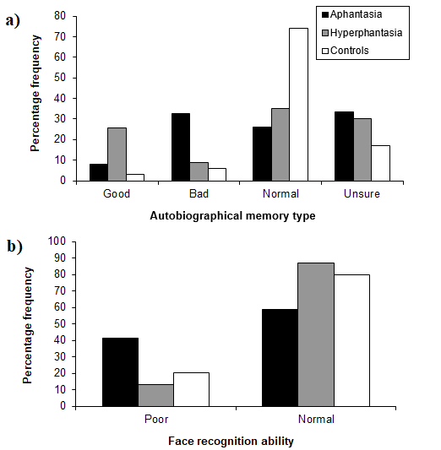
Figure 1: Percentage of participants with aphantasia, hyperphantasia and controls reporting a) good, bad or normal autobiographical memory or who were unsure; b) difficulty (poor) or no difficulty (normal) with face recognition.

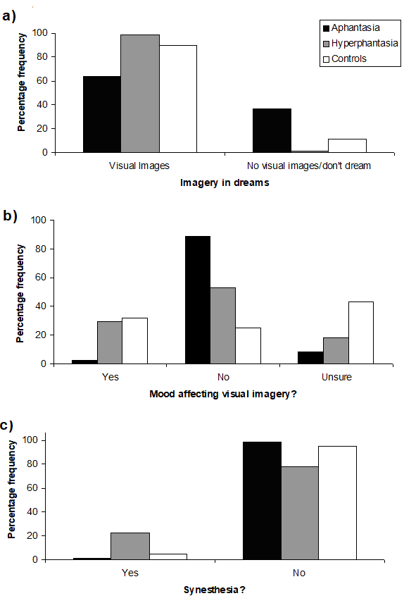
Figure 2: Percentage of participants with aphantasia, hyperphantasia and controls reporting a) visual images in dreams vs those reporting no visual imagery or absence of dreaming; b) that their mood affected the vividness of their visual imagery, or that they are unsure; c) the experience of synaesthesia.

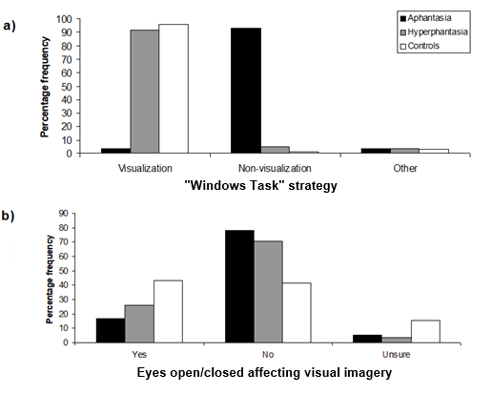

Figure 3: Percentage of participants with aphantasia, hyperphantasia and controls reporting a) the use of ‘visualisation’ vs ‘non-visualisation’ strategies to count mentally the number of windows in their house or apartment vs ‘other’ responses; b) that the vividness of visual imagery is affected by having their eyes open vs closed or that they are unsure.

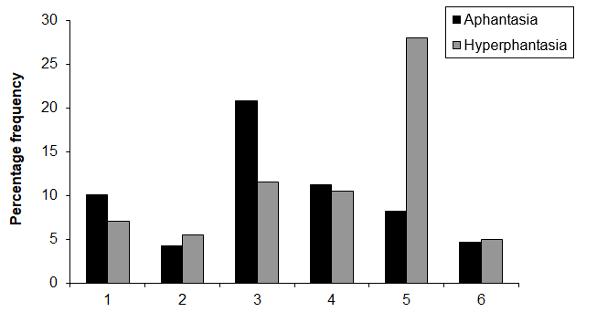

Figure 4: Percentage of participants with aphantasia and hyperphantasia reporting their occupation as being: 1 = Management, 2 = Business and financial; 3 = Computer and mathematical/Life, physical, social science; 4 = Education, training, and library; 5 = Arts, design, entertainment, sports and media; 6 = Healthcare, practitioners and technical. Only categories where the percentage frequency for either group exceeded 5% are included. A full breakdown of the distribution is displayed in Supplementary Table 1.

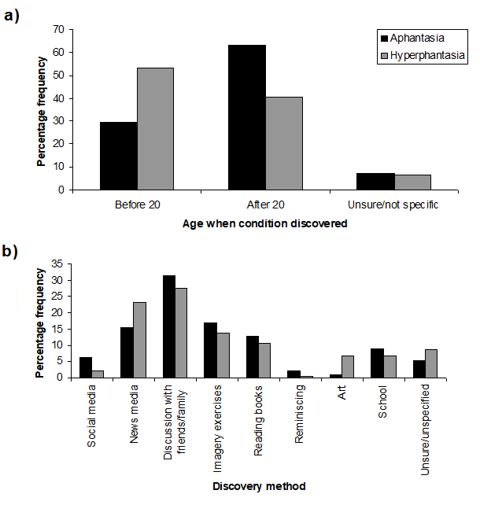

Figure 5: a) Percentage of participants with aphantasia and hyperphantasia who became aware of their extreme imagery vividness before and after the age of 20 vs those unsure; b) Mode of discovery of aphantasia and hyperphantasia.

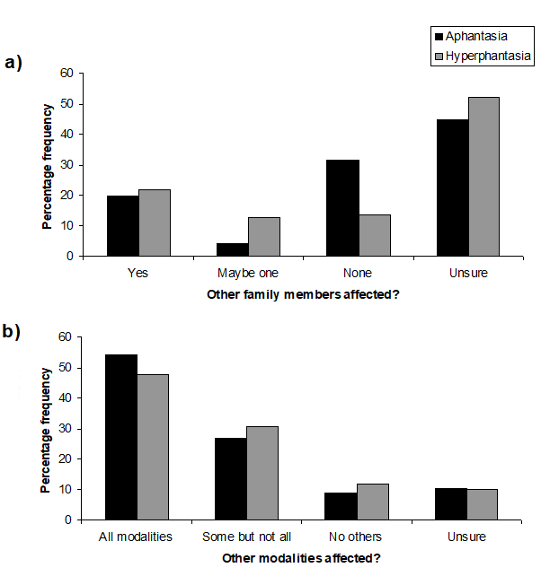
Figure 6: Percentage of participants with aphantasia and hyperphantasia reporting a) affected family members; b) that imagery in other sensory modalities was similarly affected (‘all modalities’ implies that all modalities are faint or absent in the case of aphantasia, extremely vivid in the case of hyperphantasia).

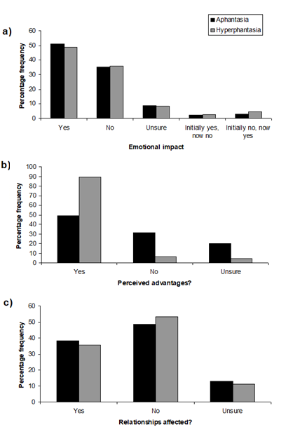
Figure 7: Percentage of participants with aphantasia and hyperphantasia reporting a) perceived advantages of their imagery status; b) an emotional impact from the discovery of their imagery status; c) that their relationships have been affected by their imagery status.

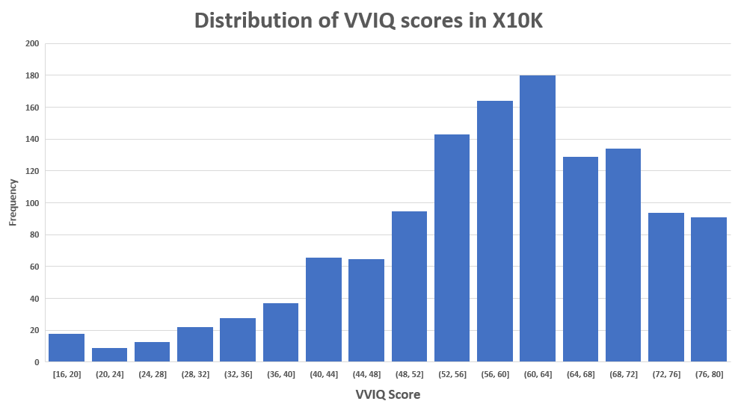
Figure 8: The distribution of VVIQ scores in the Extend (X10K) community sample (n=1288).

Reference List

Aristotle. (1968). De Anima. Books II and III (with certain passages from Book I) (D.W. Hamlyn, Trans.). Oxford: Clarendon Press.
Barnett, K.J., & Newell, F.N. (2008). Synaesthesia is associated with enhanced, self-rated visual imagery. Conscious. Cogn, 17(3), 1032-1039. doi:S1053-8100(07)00056-6 [pii];10.1016/j.concog.2007.05.011 [doi]
Bartolomeo, P. (2008). The neural correlates of visual mental imagery: an ongoing debate. Cortex, 44(2), 107-108. doi:S0010-9452(07)00016-0 [pii];10.1016/j.cortex.2006.07.001 [doi]
Bickerton, Derek. (2014). More than Nature Needs: Language, Mind and Evolution. Cambridge, Mass.: Harvard University Press.
Blazhenkova, O., & Kozhevnikov, M. (2010). Visual-object ability: a new dimension of non-verbal intelligence. Cognition, 117(3), 276-301. doi:S0010-0277(10)00201-5 [pii];10.1016/j.cognition.2010.08.021 [doi]
Blood, A.J., & Zatorre, R.J. (2001). Intensely pleasurable responses to music correlate with activity in brain regions implicated in reward and emotion. Proc. Natl. Acad. Sci. U. S. A, 98(20), 11818-11823.
Brewer, W.F., & Schommer-Aikins, M. (2006). Scientists are not deficient in visual imagery: Galton revisited. Review of General Psychology, 10(2), 130-146.
Brosch, R. (2018). What we 'see' when we read: Visualization and vividness in reading fictional narratives. Cortex, 105, 135-143. doi:10.1016/j.cortex.2017.08.020
Clemens, A. When the Eye's Mind is Blind. Scientific American.
D'Aloisio-Montilla, Nicholas. (2017). Imagery and overflow: we see more than we report Philosophical Psychology. doi:http://dx.doi.org/10.1080/09515089.2017.1298086
D'Argembeau, A., & Van der Linden, M. (2006). Individual differences in the phenomenology of mental time travel: The effect of vivid visual imagery and emotion regulation strategies. Conscious Cogn, 15(2), 342-350. doi:10.1016/j.concog.2005.09.001
Daselaar, S.M., Rice, H.J., Greenberg, D.L., Cabeza, R., LaBar, K.S., & Rubin, D.C. (2008). The spatiotemporal dynamics of autobiographical memory: neural correlates of recall, emotional intensity, and reliving. Cereb. Cortex, 18(1), 217-229. doi:bhm048 [pii];10.1093/cercor/bhm048 [doi]
Farah, M.J. (1984). The neurological basis of mental imagery: a componential analysis. Cognition, 18, 245-272.
Faw, Bill. (2009). Conflicting intuitions may be based on differing abilities - evidence from mental imaging research. Journal of Consciousness Studies, 16, 45-68.
Ffytche, D.H., Howard, R.J., Brammer, M.J., David, A., Woodruff, P., & Williams, S. (1998). The anatomy of conscious vision: an fMRI study of visual hallucinations. Nat. Neurosci, 1(8), 738-742.
Fulford, J., Milton, F., Salas, D., Smith, A., Simler, A., Winlove, C., & Zeman, A. (2018). The neural correlates of visual imagery vividness - An fMRI study and literature review. Cortex, 105, 26-40. doi:10.1016/j.cortex.2017.09.014
Galton, Francis. (1880). Statistics of mental imagery. Mind, 5, 301-318.
Gilboa, A., Winocur, G., Grady, C.L., Hevenor, S.J., & Moscovitch, M. (2004). Remembering our past: functional neuroanatomy of recollection of recent and very remote personal events. Cereb. Cortex, 14(11), 1214-1225. doi:10.1093/cercor/bhh082 [doi];bhh082 [pii]
Greenberg, D.L., & Knowlton, B.J. (2014). The role of visual imagery in autobiographical memory. Mem. Cognit, 42(6), 922-934. doi:10.3758/s13421-014-0402-5 [doi]
Gruter, T., Gruter, M., Bell, V., & Carbon, C.C. (2009). Visual mental imagery in congenital prosopagnosia. Neurosci. Lett, 453(3), 135-140. doi:S0304-3940(09)00181-5 [pii];10.1016/j.neulet.2009.02.021 [doi]
Holmes, E.A., & Mathews, A. (2010). Mental imagery in emotion and emotional disorders. Clin. Psychol. Rev, 30(3), 349-362. doi:S0272-7358(10)00014-0 [pii];10.1016/j.cpr.2010.01.001 [doi]
Hurlburt, R.T., & Schwitzgebel, E. (2007). Describing Inner Experience: proponent meets sceptic. Cambridge, Massachusets: MIT Press.
Jacobs, C., Schwarzkopf, D. S., & Silvanto, J. (2018). Visual working memory performance in aphantasia. Cortex, 105, 61-73. doi:10.1016/j.cortex.2017.10.014
Keogh, R., & Pearson, J. (2018). The blind mind: No sensory visual imagery in aphantasia. Cortex, 105, 53-60. doi:10.1016/j.cortex.2017.10.012
Logie, Robert. (2018). Human Cognition: common principles and individual variation. Journal of Applies Research in Memory and Cognition, 7, 471-486.
Lu, J., Sherman, D., Devor, M., & Saper, C. B. (2006). A putative flip-flop switch for control of REM sleep. Nature, 441(7093), 589-594. doi:10.1038/nature04767
Macdonald, P.L.; Gardner, R.C. (2000). Type I error rate comparisons of post hoc procedures for I J chi-square tables. . Educational and Psychological Measurement, 60, 735-754.
Marks, D.F. (1973). Visual imagery differences in the recall of pictures. British Journal of Psychology, 64, 17-24.
McKelvie, SJ. (1995). The VVIQ as a psychometric test of individual differences in visual imagery vividness: a crticial quantitative review and plea for direction. Journal of Mental Imagery, 19, 1-106.
Miller, Lauren. (2017). All Things New. LA, USA: Three Saints Press
Munzert, J.; Lorey, B. (2013). Motor and Visual Imagery in Sports. In S.; Lawson Lacey, R. (Ed.), Multisensory Imagery (pp. 319-341). New York: Springer.
Otis, Laura. (2015). Rethinking Thought. Oxford: Oxford University Press.
Owen, A.M., Coleman, M.R., Boly, M., Davis, M.H., Laureys, S., & Pickard, J.D. (2006). Detecting awareness in the vegetative state. Science, 313(5792), 1402.
Pearson, J., Naselaris, T., Holmes, E.A., & Kosslyn, S.M. (2015). Mental Imagery: Functional Mechanisms and Clinical Applications. Trends Cogn Sci, 19(10), 590-602. doi:S1364-6613(15)00180-1 [pii];10.1016/j.tics.2015.08.003 [doi]
Ross, Blake. Aphantasia: How It Feels To Be Blind in your Mind. Retrieved from https://www.facebook.com/notes/blake-ross/aphantasia-how-it-feels-to-be-blind-in-your-mind/10156834777480504/
Rubin, D.C., & Greenberg, D.L. (1998). Visual memory-deficit amnesia: a distinct amnesic presentation and etiology. Proc. Natl. Acad. Sci. U. S. A, 95(9), 5413-5416.
Schacter, D.L., & Addis, D.R. (2007). The cognitive neuroscience of constructive memory: remembering the past and imagining the future. Philos. Trans. R. Soc. Lond B Biol. Sci, 362(1481), 773-786.
Sheldon, S., Farb, N., Palombo, D. J., & Levine, B. (2016). Intrinsic medial temporal lobe connectivity relates to individual differences in episodic autobiographical remembering. Cortex, 74, 206-216. doi:10.1016/j.cortex.2015.11.005
Shepard, Roger. (1988). The Imagination of the Scientist. In K Egan & D Nadaner (Eds.), Imagination and Education (pp. 153-185). Milton Keynes: Open University Press. (Reprinted from: Not in File).
Smallwood, J., & Schooler, J.W. (2015). The science of mind wandering: empirically navigating the stream of consciousness. Annu. Rev. Psychol, 66, 487-518. doi:10.1146/annurev-psych-010814-015331 [doi]
Vannucci, M., Mazzoni, G., Chiorri, C., & Cioli, L. (2008). Object imagery and object identification: object imagers are better at identifying spatially-filtered visual objects. Cogn Process, 9(2), 137-143. doi:10.1007/s10339-008-0203-5
Vannucci, M., Pelagatti, C., Chiorri, C., & Mazzoni, G. (2016). Visual object imagery and autobiographical memory: Object Imagers are better at remembering their personal past. Memory, 24(4), 455-470. doi:10.1080/09658211.2015.1018277
Wicken, M., Keogh, R., & Pearson, J. (2019). The critical role of mental imagery in human emotion: insights from Aphantasia. bioRxiv. doi:https://doi.org/10.1101/726844
Winlove, C. I. P., Milton, F., Ranson, J., Fulford, J., MacKisack, M., Macpherson, F., & Zeman, A. (2018). The neural correlates of visual imagery: A co-ordinate-based meta-analysis. Cortex. doi:10.1016/j.cortex.2017.12.014
Zago, S., Allegri, N., Cristoffanini, M., Ferrucci, R., Porta, M., & Priori, A. (2011). Is the Charcot and Bernard case (1883) of loss of visual imagery really based on neurological impairment? Cogn Neuropsychiatry, 16(6), 481-504. doi:937908818 [pii];10.1080/13546805.2011.556024 [doi]
Zeman, A., Dewar, M., & Della Sala, S. (2015). Lives without imagery - Congenital aphantasia. Cortex, 73, 378-380. doi:S0010-9452(15)00178-1 [pii];10.1016/j.cortex.2015.05.019 [doi]
Zeman, A.Z., Della Sala, S., Torrens, L.A., Gountouna, V.E., McGonigle, D.J., & Logie, R.H. (2010). Loss of imagery phenomenology with intact visuo-spatial task performance: a case of 'blind imagination'. Neuropsychologia, 48(1), 145-155. doi:S0028-3932(09)00341-8 [pii];10.1016/j.neuropsychologia.2009.08.024 [doi]

Acknowledgments: We are grateful to the many individuals who have contacted us about their extreme imagination, especially those completing the questionnaires on which this paper is based; we thank Mathew Jaquiery for IT assistance, David Mitchell for philological advice informing the choice of the term ‘aphantasia’, Helen Ryland for administrative help and undergraduate interns at Exeter (Tatiana Amore, Carla Black, Zoe Foster, Mada Radu, Rosanna Weatherly, Rebecca Woodrow) for assistance in responding to the 12,000 contacts. Funding: United Kingdom Arts and Humanities Research Council Science in Culture Innovation Award: The Eye's Mind - a study of the neural basis of visual imagination and its role in culture AH/M002756/1; Follow-on Funding Award: Extreme Imagination in Mind, Brain and Culture AH/R004684/1.

Author contributions: Conceptualisation: Zeman; Data curation: Gaddum, Hattersley, Heuerman-Williamson, Jones, Mackisack; Formal analysis: Dewar, Frayling, Milton; Funding acquisition: Zeman; Investigation: Gaddum, Heuerman-Williamson, Jones, Winlove, Zeman, ; Methodology: Della Sala, Dewar, Zeman; Project administration: Hattersley, Winlove, Zeman; Resources: Zeman; Supervision: Zeman ; Validation: Della Sala, Dewar, Zeman; Visualization: Milton; Writing – original draft: Zeman; Writing – review and editing: all authors.

Competing interests: Authors declare no competing interests.

