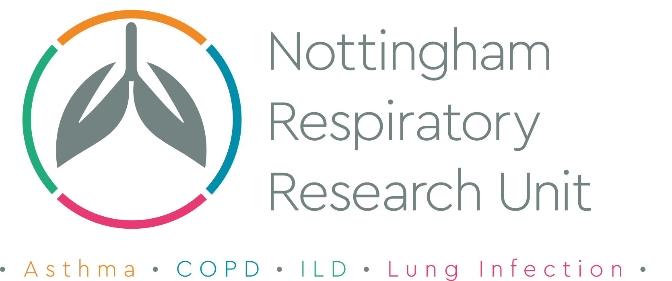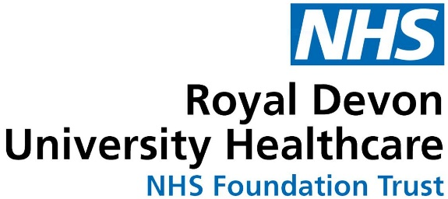

Participant Information Sheet
(Version 1.5 12th March 2021)

IRAS Project ID: 237010

Title of Study: It’s Not JUST Idiopathic Pulmonary FibrosiS Study

Name of Chief Investigator: Professor Simon Johnson

We would like to invite you to take part in our research study. Before you decide we would like you to understand why the research is being done and what it would involve for you. One of our team will go through the information sheet with you and answer any questions you have. Talk to others about the study if you wish. Ask us if there is anything that is not clear.

What is the purpose of the study?
Fibrotic lung conditions result in scarring of the lung tissue. This causes shortness of breath and cough, and has an enormous impact on people’s quality of life. We currently know that progressive lung scarring may be caused by a few conditions like Rheumatoid Arthritis and previous exposure to asbestos, birds (pigeons, parrots and budgies particularly) and moulds. In cases where no cause is found, we sometimes refer to this type of lung scarring as Idiopathic Pulmonary Fibrosis (IPF). However, regardless of whether a cause is found, or not, we do not have a cure.
The aim of these studies is to understand whether patients with progressive pulmonary fibrosis, regardless of the cause, have shared reasons for their disease progression. We will do this by assessing whether the genetic, cellular and chemical signals in the blood of people with IPF and other lung scarring conditions are similar or different. We also need to understand how these conditions change over time. Researchers wish to study the genetic signatures in samples and hope it will lead to a better understanding of why people develop lung fibrosis regardless of its cause and how the disease and its symptoms progress.

Why have I been invited?
You are being invited to take part because your doctor has given you a diagnosis of fibrotic lung disease. Specifically, we are asking patients who have been told they have RA-UIP, Asbestosis, Chronic Hypersensitivity Pneumonitis and Unclassifiable Fibrotic Lung Disease or Idiopathic Pulmonary Fibrosis to help us with the study. We are inviting 250 participants like you to take part.

Do I have to take part?
It is up to you to decide whether or not to take part. If you do decide to take part, you will be given this information sheet to keep and be asked to sign a consent form. If you decide to take part, you are still free to withdraw at any time and without giving a reason. This would not affect your legal rights.

What will happen to me if I take part?
If, after reading this information sheet and talking to a member of the research team, you would like to take part in this study, we will ask you to sign a consent form.

This study will last for 2 years and during this time you will need to have various tests/procedures and will need to attend the hospital that recruited you to the study for study visits at specific times (an initial visit and then again 3 months, 12 months and 24 months later, four visits in total).

The following test results taken as part of your routine NHS care will be used by researchers for the purposes of this study:

• CT Chest Scan findings
• Lung Function test results
• Bronchoscopy if clinically indicated: We will ask for consent to obtain additional research samples.
• Blood Test results

The following tests/procedures will be performed as part of the research study:

• Questionnaires: You will be asked to fill out 5 short questionnaires (Leicester Cough Questionnaire, The Kings Brief Interstitial Lung Disease Questionnaire, The Medical Research Council Dyspnoea Scale, EQ-5D-5L and the IPARC score) These forms ask questions about your lung fibrosis and how it effects your daily life.
• Blood Test: We would like to take a 40ml sample (the equivalent to 3 tablespoons) of blood at each of the four visits (initial visit, and then 3, 12 and 24 months). Samples for analysis of serum, plasma, blood cells, RNA and genetic analysis (optional) will be taken.
• Walking Test: we would like to assess how far you can walk in 6 minutes. We will ask you to walk from one end of the corridor to the other at your own pace, trying to cover as much ground as possible. You can stop and rest at any time. After six minutes, you will be asked to stop and the distance you have walked will be measured and any symptoms you had during the test are written down.
• Bronchoscopy (Optional): If bronchoscopy is not clinically indicated, we will request some patients to undergo this test as part of research. It will be done in accordance with endoscopy guidelines and additional information (leaflet) will be given. You can withdraw your consent at any time and can choose to not undergo this test for research purposes. You can however, still take part in the main study.

- Hand Held Spirometry : You will be provided with a small hand held spirometer to blow into (to measure breathing tests). This device connects with a smartphone application ‘app’ (called “patientMpower app”) which will download the breathing test information onto your smartphone. We will give you full training on how to use this.

We want you to use the home spirometer for the first three months of the study every day and then at the same time as your follow ups at 3 months, 12 months and 24 months (the week before and the week after these appointments)

You will be asked to do one home spirometry breathing test (sitting down) ideally at about the same time of day.

During the first three months you will not be able to see the results of the breathing tests done at home, but after the initial three-month period and your second study visit your results will be unblended and you will be able to see them. The device is yours to keep.

The following table gives an overview of the various tests done as part of routine care and as part of the research study for those who have been asked to take part.

Tests Done As Part of Routine Care: | Tests Done as Part of Research:
Lung Function Tests at initial visit, 3, 12 and 24 months | Questionnaires at all visits
Blood Test to look for any underlying causes of lung fibrosis | Blood test (40ml at all visits)  Walking Test at all visits
Bronchoscopy if clinically indicated (only for patients whose chest scans have shown enlarged lymph nodes) | Daily Spirometry at home (with hand-held spirometer) for 3 months and then for two weeks (one before and one after) follow up appointments  Bronchoscopy as part of research (optional)

Expenses and payments

Travel expenses will be offered for any additional visits incurred as a result of participation. Participants will not be paid to participate in the study.

What are the possible disadvantages and risks of taking part?
As with all tests/procedures some people experience side effects, some of which are detailed below:

• Blood Tests: Occasionally some people feel faint during a blood test. If this occurs please tell the person doing the test, as you should immediately lie down to prevent fainting. Sometimes after donating blood, a bruise develops where the needle was inserted.
• Walking Test: Changes in blood pressure and heart rate, dizziness, chest pain and very rarely fainting can happen. You may feel increasingly short of breath. This is because we are testing your body’s ability to withstand exercise. There will be a chair available at both ends of the corridor in case you must rest and you can stop at any time.
• Bronchoscopy: This test has its’ risk outlined in the hospital Bronchoscopy booklet, which will be given in accordance with endoscopy guidelines. You will be given minimum of 24hours to ask any queries prior to obtaining consent.
- Home Spirometry: The spirometer is not known to have any adverse effects. As with normal spirometry tests, breathing out forcefully can sometimes make you feel faint and we would recommend you undertake the breathing test sitting down. Similarly breathing tests can make you cough.

What are the possible benefits of taking part?
We cannot promise the study will help you but the information we get from this study may help us to gain a greater understanding of why people do or do not develop Lung Fibrosis.

What happens when the research study stops?

We do not expect to end the study early. However, if research does unexpectedly end then we would always let you know that the study has stopped. When the study does come to an end, after you have participated for the 2-year period, your care will go back to the same as before with your normal follow up visits to your doctor.

What if there is a problem?
If you have a concern about any aspect of this study, you should ask to speak to the researchers who will do their best to answer your questions. The researchers’ contact details are given at the end of this information sheet. If you remain unhappy and wish to complain formally, you can do this by contacting

NUH NHS Trust, c/o PALS
Freepost NEA 14614
Nottingham NG7 1BR
Tel: 0800 183 02 04
Email: pals@nuh.nhs.uk

In the event that something does go wrong and you are harmed during the research and this is due to someone's negligence then you may have grounds for a legal action for compensation against the University of Nottingham but you may have to pay your legal costs. The normal National Health Service complaints mechanisms will still be available to you.

Will my taking part in the study be kept confidential?

We will follow ethical and legal practice and all information about you will be handled in confidence.

If you join the study, we will use information collected from you and your medical records during the course of the research. This information will be kept strictly confidential, stored in a secure and locked office, and on a password protected database at the University of Nottingham. Under UK Data Protection laws the University is the Data Controller (legally responsible for the data security) and the Chief Investigator of this study (named above) is the Data Custodian (manages access to the data). This means we are responsible for looking after your information and using it properly. Your rights to access, change or move your information are limited as we need to manage your information in specific ways to comply with certain laws and for the research to be reliable and accurate. To safeguard your rights, we will use the minimum personally – identifiable information possible.

You can find out more about how we use your information and to read our privacy notice at:

https://www.nottingham.ac.uk/utilities/privacy.aspx.

The data collected for the study will be looked at and stored by authorised persons from the University of Nottingham who are organising the research. They may also be looked at by authorised people from regulatory organisations to check that the study is being carried out correctly. All will have a duty of confidentiality to you as a research participant and we will do our best to meet this duty.

Where possible, information about you which leaves the hospital will have your name and address removed and a unique code will be used so that you cannot be recognised from it, however sometimes we need to ensure that we can recognise you to link the research data with your medical records so in these instances we will need to know your name and date of birth. We will also need this information if we need to follow up your medical records as part of the research, where we may need to ask the Government services that hold medical information about you (such as NHS Digital, the Office for National Statistics, among others) to provide this information to us. By signing the consent form you agree to the above.

Your contact information will be kept by the University of Nottingham for 10 years after the end of the study so that we are able to contact you about the findings of the study and possible follow-up studies (unless you advise us that you do not wish to be contacted). This information will be kept separately from the research data collected and only those who need to will have access to it. All other data (research data) will be kept securely for 7 years. After this time your data will be disposed of securely. During this time all precautions will be taken by all those involved to maintain your confidentiality, only members of the research team given permission by the data custodian will have access to your personal data.

In accordance with the University of Nottingham’s, the Government’s and our funders’ policies we may share our research data with researchers in other Universities and organisations, including those in other countries, for research in health and social care. Sharing research data is important to allow peer scrutiny, re-use (and therefore avoiding duplication of research) and to understand the bigger picture in particular areas of research. Data sharing in this way is usually anonymised (so that you could not be identified) but if we need to share identifiable information we will seek your consent for this and ensure it is secure. You will be made aware then if the data is to be shared with countries whose data protection laws differ to those of the UK and how we will protect your confidentiality.

Because of taking part in the home spirometry part of the study, your email address will be known to patientMpower Ltd. (They need this information to manage your password access, provide individualised technical support to you and be able to delete your data in case you request that at some time in the future). The patientMpower app can automatically record your geographical location if you give permission in the app. If you do this, the patientMpower app can give you information on the air quality at your location. In this case, patientMpower can know the location of your phone. However, you do not have to give this permission in the app if you don’t want to.

All information (including spirometry data) recorded on the patientMpower app will be kept confidential. This information is stored in a secure cloud system which is maintained by patientMpower Ltd., Digital Depot, Dublin 8, Ireland (who developed the app). This cloud system is designed with strict security measures which meet current industry standards for health-related information. Information recorded on the patientMpower app will be viewed and analysed by named and authorised users at patientMpower Ltd and the University of Nottingham research team. The spirometry data on the patientMpower app will be transferred to the University of Nottingham. patientMpower Ltd will be acting as the Data Processor (they will process your personal information on behalf of the University) and the University will be the Data Controller (the University decides how the data is processed and takes responsibility for it). Both have safeguards in place to protect your data.

If you wish to have information deleted from the patientMpower app this can be done on request to patientMpower Ltd. You can contact them at www.info.patientmpower.com or by phone at 020 3322 4121 or using the support button within the app itself.

What will happen if I don’t want to carry on with the study?
Your participation is voluntary and you are free to withdraw at any time, without giving any reason, and without your legal rights being affected. If you withdraw we will no longer collect any information about you or from you but we will keep the information about you that we have already obtained as we are not allowed to tamper with study records and this information may have already been used in some analyses and may still be used in the final study analyses. To safeguard your rights, we will use the minimum personally-identifiable information possible.

Involvement of the General Practitioner/Family doctor (GP)
With your permission, we will write to your GP to notify them that you are going to take part in this study. We will also, with your permission, notify you and your GP of any clinically relevant abnormal test results that might need further action. However, abnormal test results that form part of our analysis (e.g. genetic or immunological analysis) for which the clinical implications are not yet certain will not be communicated to you or your GP.

What will happen to any samples I give?
Any tissue/blood sample you donate will be stored in a secure research facility at the University of Nottingham (Respiratory Research Unit) for as long as is required for the purposes of this study. Your sample will have your initials, date of birth and a number/code that is unique to yourself. By using these numbers, we can trace which sample belongs to you. This is important for the current study, so that we can re-test your sample if there is a problem with our tests.

We would also like to seek your consent so that any remaining samples may be stored and used in possible future research – this is optional (please indicate you agree to this on the consent form). The samples will be stored with a code unique to you and securely at the University of Nottingham under the University’s Human Tissue Research Licence (no 12265).
Some of these future studies may be carried out by researchers other than current team, who ran the first study, including researchers working for commercial companies. Any samples or data used will be anonymised, and you will not be identified in anyway. If you do not agree to this any remaining samples will be disposed of in accordance with the Human Tissue Authority’s codes of practice.

Will any genetic tests be done?
Yes. It is hoped that the genetics part of the study (looking for differences in people’s genes) will lead to a greater understanding of why people do or do not develop Lung Fibrosis and why some people react differently when they get it. We will be looking at genes that affect lung fibrosis.
Joining this part of the study is optional. This means you may:
• Choose not to join the genetics part of the study but still take part in the main study
• Choose not to join then change your mind before your sample is taken or at any time in the study
• Choose not to join at this time but decide to join later. If so, please talk to your study doctor.

Please be aware that the results of any genetic testing will be strictly confidential and will not be sent out to you.
If you choose after giving a sample not to take part in the genetics part of the study, we will destroy your sample within 30 days. If you choose to withdraw from the whole study after giving a sample, we will also destroy your sample within 30 days. However, if your sample is being processed we will have to wait until the laboratories have finished their tests before we can destroy it. This might take longer than 30 days. Please note, in this event, that we will not use your data for analysis.

What will happen to the results of the research study?
We intend to publish the results of this study in a medical respiratory journal. A summary of these results will also be made available on the Nottingham Respiratory Research Units website www.nrru.org.uk

Who is organising and funding the research?
This research is being organised by the University of Nottingham and is being funded by the NIHR Nottingham Biomedical Research Centre.

Who has reviewed the study?
All research in healthcare is looked at by independent group of people, called a Research Ethics Committee, to protect your interests. This study has been reviewed and given favourable opinion by East Midlands – Nottingham 1 Research Ethics Committee.

Further information and contact details

Research Officer: Lucy Howard
Tel: 0115 8231326
Email: lucy.howard@nottingham.ac.uk

Or

Dr Fasihul Khan
Tel: 0115 8231702
Email: fasihul.khan@nottingham.ac.uk

