Participant Information Sheet

MucAct COPD Study

You are invited to take part in a research study. To help you decide whether or not to take part, it is important for you to understand why the research is being done and what it will involve. Please take time to read the following information carefully. Talk to others about the study if you wish. Contact us if there is anything that is not clear, or if you would like more information. Take time to decide whether or not you wish to take part.

What is the purpose of the study?
Some patients with Chronic Obstructive Pulmonary Disease (COPD) find it hard to clear sputum (phlegm) from the airways. Unfortunately, there’s no good evidence that shows the best treatment for patients.

We want to study whether breathing in sodium chloride (salty water) through a nebuliser can help patients with COPD cough up phlegm, make them feel better and cut down the number of chest infections they get. We also would like to know whether this is better than taking tablets (a drug known as carbocisteine), which are also thought to help patients clear phlegm from the chest.

We will invite 860 patients with COPD in the UK to take part in the study.

Why have I been invited to take part?
You have been asked to take part as you have been diagnosed with COPD and one of the doctors looking after you think you might be suitable to take part.
Do I have to take part?
No, it is up to you to decide whether or not to take part. If you do decide to take part you will be given this information sheet to keep and be asked to sign a consent form. If you decide to take part you are still free to withdraw at any time and without giving a reason. Deciding not to take part or withdrawing from the study will not affect the healthcare that you receive, or your legal rights.

What will happen if I take part?
Once you have read this leaflet, you can have as much time as you need to decide whether or not you wish to take part. If you have received this leaflet at a clinic visit we will arrange to phone you back in a week to see if you have any questions or have reached a decision.

If you want to take part, you can return the Consent to Researcher Contact Form using the prepaid envelope or call the research team on 01392 406901/6981

We will then make an appointment for you to attend Royal Devon and Exeter Hospital or we may do the appointment remotely using phone or videoconferencing if it is not possible for you to attend. If this is the case, we will send you all the equipment you need to take part to you. At the appointment, the researcher will discuss each part of the study with you and answer any questions you have. If you are happy to take part, we will ask you to sign a consent form.

You will be asked to attend three appointments in total – one to join the study and again at 6 months and 1 year. If you are unable to attend the research site for your appointment, we can arrange to carry this out remotely using videoconference facilities. These will take around 2 hours to complete. You will be asked to do the following:

Screening (first appointment only) – 10 minutes
The researcher will ask you questions about your health to see whether or not you are suitable to take part in the study. We will collect information from you which will include your name and address, telephone number, email address (if you have one), date of birth, NHS number (e.g. CHI number), demographics and medical history.

Pregnancy Test – 5 minutes
If you are female, and are of childbearing age, we will ask you to take a pregnancy test before you enter the study, as taking one of the study drugs is not advisable for pregnant women.

Spirometry Lung Test – 20 minutes
A spirometry test will be completed at each appointment to see how well your lungs work. Spirometry measures the amount of air you can breathe out from your lungs and how fast you can blow it out. You’ll be asked to take a very deep breath and blow out as fast as you can into a mouthpiece, until no more air comes out. We will ask you to do this test at least 60 minutes after you to take your regular inhalers (only if you are on inhalers normally for your chest).

Randomisation – 5 minutes
The researcher will then use a computer to randomly (i.e. by 50/50 chance) put you into one of two groups:

- Inhale sodium chloride (salty water) through a nebuliser twice a day for 1 year. A nebuliser is a machine that creates a mist, which can be inhaled through a mask or tube to help clear excess mucus from the airways.

- Take carbocisteine tablets daily for 1 year. These will be taken three times a day for the first 8 weeks then twice a day for the rest of the year.

It is not possible for it to be a blind trial because the people taking part and the research team will obviously know the treatment given.

Prescription and dosing instructions – 30 minutes
If you are in the group using a nebuliser we will teach you how to use this and how to clean it. We ask that you use your nebuliser with your study medication (1 x 4 mL ampoule of 7% sodium chloride) 2 times a day for 52 weeks.

If you are in the group taking the carbocisteine tablets, we ask that you take 2 x 375mg tablets three times a day for 8 weeks until week 9, when you will reduce this to 2 x 375mg tablets twice a day.

For each group, we will give you a prescription for a 3 month supply of the medication you need at the first appointment and then every 3 months whilst on the study.

Returning medication– 5 minutes
At the end of each prescription period, when you have received your new supply of medication we will ask you to return any unused medication to your hospital or local pharmacy (in accordance with local practice) so they can be destroyed.

Breathing and Coughing Techniques – 20 minutes
Everyone will be taught chest clearance at the first appointment using a video of breathing and coughing techniques and an information sheet that they can use twice a day to help clear phlegm from the chest.

Sputum Test – 5 minutes
If you are able to cough up a sputum (phlegm) sample during each appointment we will collect this to test it for infections. You will be asked to return this to your GP or local hospital if you collect it at home.

We will ask for your permission to keep this for future research (optional).

Weekly Diary/Exacerbation Diary – 15 minutes
We will ask you to complete a diary each week for one year so that you can record any flare ups you have, whether or not you have taken medication and whether you have any side-effects from the study medication. We will also ask if you or a member of your household have caught any colds or viruses. We will provide you with paper copies for you to complete and return by post every 2 months. There will be 52 weekly diaries for you to complete and these will take you approximately 15 minutes each. If you do have a flare-up, we will ask you to complete the Exacerbation Diary which will take you an additional 5 minutes each day to complete (for up to 14 days). We will provide you with a study tote bag so you can keep your study documentation in one place, and a study pen to complete your diaries.

Questionnaires – 20 minutes
We will ask you to complete a questionnaire at each appointment which will ask you about lung infections, coughs, your wellbeing and quality of life and how often you have used healthcare services. You will complete one at your first appointment and we will send the 6 and 12 month questionnaires to you by email one week before your 6 and 12 month appointments. If for any reason you are unable to complete the questionnaires electronically, your local research team can provide you with a paper copy. There are 3 questionnaires to complete during the study and these will take approximately 20 minutes to complete each time.

Phone Call (every 8 weeks) – 15 minutes
The research team will call you within the first 4 weeks of your participation in the study to see how you are getting on. The research team will then call you once every 8 weeks to discuss again how you are getting on with the study medication and review the information you have recorded in your weekly diary.
Below we have provided a summary of what you will be asked to do as a participant in the study
Study involvement:

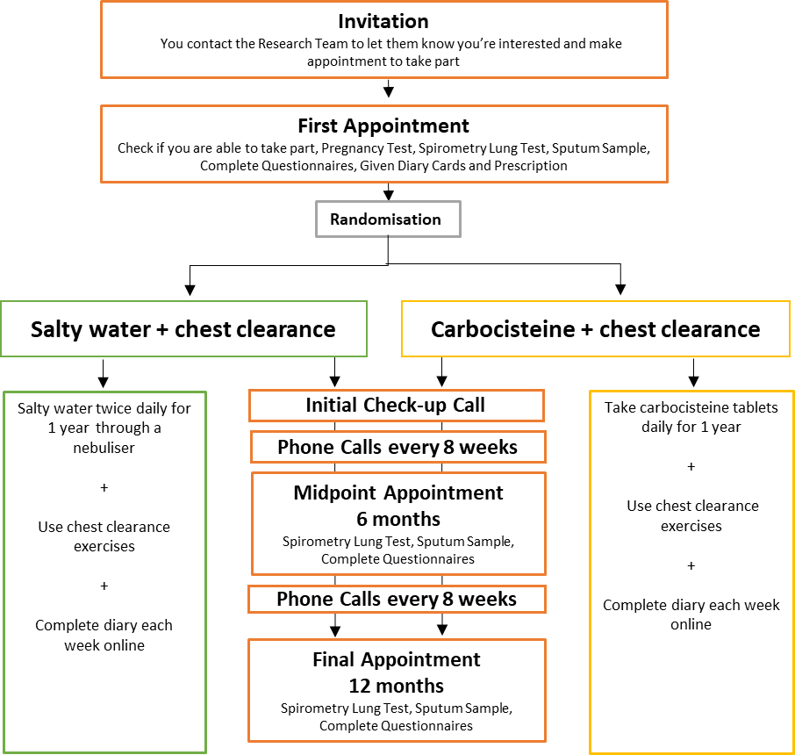

Telephone Interview Study (optional linked research study) – 45 minutes
In order to make sure this study runs as well as possible, researchers at the University of Stirling will be inviting a small number of the participants taking part to give feedback in a telephone interview lasting around 30-45 minutes. If you choose to take part in the telephone interview, it will be recorded and anonymised to use for training purposes. It is also possible that one of your phone calls mentioned above will be recorded in the same way.

If you tell us you are interested in taking part in this separate interview study we would pass your name and phone number to the research team so they could contact you with more information.

If you do not wish to take part in the MucAct COPD study, we will not ask you why you have decided this. To learn why participants do not take part in studies, however, would you be happy to do a short interview with other researchers to discuss the reasons why? If so, then please complete the consent to be contacted form.
Is there anything I need to do or avoid?
For the Spirometry Lung Test at each appointment you need to do the following to prepare:

Avoid eating a large meal for 2 hours before the test
Avoid caffeine on the day of your test
Avoid vigorous exercise for 30 minutes before the test
If you use an inhaler, make sure you have taken this at least 60minutes before the test
Bring your inhalers (plus any spacer device) to the appointment
Wear loose fitting comfortable clothing

For safety reasons, during the COVID 19 pandemic, the study team would recommend;
- Performing airway clearance techniques by yourself in a room with an open window.
- If using the nebuliser, perform by yourself in a room with an open window.
- Other family members not to enter the room for 60 minutes after you have finished.
Others helping and handling the mask and nebuliser equipment (if using this) should be advised on good hand hygiene to minimise risk of infection spread.

Contraception to Avoid Pregnancy
For women taking part:

To take part in the study, women of childbearing age should be using a highly effective form of contraception from when they join the study until at least 30 days after finishing. Highly effective contraception includes the ‘pill’, the coil or if you have had an operation to block the fallopian tubes. The research team will ask you about your contraception use during your appointment. If you were to become pregnant whilst you are taking part in the study, you will be withdrawn but we would ask to check your medical records until 1-2 months after the due date of the baby to review the health of you and your baby.

For men taking part:

It is not thought that the medications used in this trial can effect men’s sperm and cause problems with pregnancy so you will not be required to use contraception to avoid pregnancy. However, if your partner were to become pregnant whilst you are taking part in the study we would ask to check your partners medical records until 1-2 months after the due date of the baby to review the health of your partner and your baby.

What are the possible benefits of taking part?
There are no direct benefits to you taking part in this study, but the results from this study might help to improve the healthcare of patients in the future.

What are the possible disadvantages of taking part?
There are not thought to be many disadvantages to taking part in the study. It does involve you taking time to attend three appointments and undergo tests, complete diaries each week for a year and complete three questionnaires at each appointment which you might not find convenient.

Some patients may experience side effects from taking the study medications. Like with any new medication there is a risk of allergic reaction. You should get emergency medical help if you have any of these signs of an allergic reaction: hives; difficult breathing; swelling of your face, lips, tongue, or throat.
If you are in the group using the nebuliser you should contact the research team straight away if you have: chest pain, trouble breathing; a light-headed feeling, like you might pass out; swelling in your hands or feet; tiredness, muscle twitching; confusion, uneven heart rate, extreme thirst, increased or decreased urination, leg discomfort, muscle weakness or limp feeling.

Other common side effects for the nebuliser may include a salty taste or slight burning or irritation in your mouth. Some patients get wheezier or a tight chest with the nebulised sodium chloride (salty water). If these symptoms develop, we will add an agent to open up your airways before taking the nebulised sodium chloride (salty water). This is nebulised salbutamol which opens up your airways and allows most participants to tolerate the nebulised sodium chloride. The salbutamol can be used both before and after the nebulised sodium chloride (salty water) if needed. If still wheezy despite this, we may have to stop the nebulised sodium chloride (salty water). We estimate that these side effects could affect fewer than 10 out of 100 participants treated.

The group taking the carbocisteine tablets may experience gastrointestinal bleeding (bleeding in the stomach or intestines), vomiting or develop skin rashes and blisters. The frequency of these side effects is not known.

This is not a complete list of side effects and others may occur. We will ask you to record these in your weekly diary and the research team will discuss these with you.

Reasonable travel expenses can be given for study appointments.

Some of the questions in the questionnaire are of a sensitive nature. If completing the questionnaires have caused you to feel in any way upset and you feel you need help and support, then please see below for a list of people to contact:
• Make an appointment to see your GP to discuss your concerns.
• There are many helplines you can call if you are feeling down or want to talk. The Samaritans offer support for anyone needing someone to listen. You can call them on 116 123. More information on other support agencies can be found on the NHS website, www.nhs.uk
What if there are any problems?
If you have a concern about any aspect of this study please contact Ingrid Seath on 01392 406901/6981 who will do their best to answer your questions.

If any new information become available during the study that you need to be aware of, we would write to you to let you know.

In the unlikely event that something goes wrong and you are harmed during the research and this is due to someone’s negligence then you may have grounds for a legal action for compensation against Royal Devon University Healthcare NHS Foundation Trust but you may have to pay your legal costs. The normal National Health Service complaints mechanisms will still be available to you.

What will happen if I don’t want to carry on with the study
If you no longer want to take part, you are free to stop at any time and this will not affect the healthcare that you receive, or your legal rights. You should speak to the research team to let them know you no longer want to take part and they will discuss with you whether you want to:
- Stop taking your medication but you are happy to come in for your study appointments and for us to continue to collect information from you for the study.
- Stop taking medication, stop study appointments and stop any new information being collected about you but we will still use the information already collected up to that point for our study results.

We need to manage your records in specific ways for the research to be reliable. This means that we won’t be able to let you see or change the data we hold about you.

What happens when the study is finished?
We will retain your anonymised study data for 10 years in a secure manner in a COPD data bank. This will allow us to use the information again to do research studies in the future.

If you have given us permission to store your identifiable data or sputum samples, we might do further research about how good your health is over a number of years. We can do this research by reviewing your medical records and would not need to contact you again. This is optional and we would ask an Ethics Committee for permission before we do any new research using your information.

At the end of the study we will make the study data available for other researchers to look at. Before we make it available we will make sure it does not contain any of your personal data. Any study using your anonymised data will require review by a Research Ethics Committee.

Will my taking part be kept confidential?
All the information we collect during the course of the research will be kept confidential and there are strict laws which safeguard your privacy at every stage.

How will we use information about you?

Royal Devon and Exeter Hospital will use your name, address, date of birth, email and phone number to contact you about the research study, and make sure that relevant information about the study is recorded for your care, and to oversee the quality of the study. Individuals from NHS Lothian and The University of Edinburgh and regulatory organisations may look at your medical and research records to check the accuracy of the research study. Royal Devon and Exeter Hospital will pass these details to NHS Lothian and The University of Edinburgh along with the information collected from you and your medical records. The only people in NHS Lothian and The University of Edinburgh who will have access to information that identifies you will be people who need to contact you to send you questionnaires and weekly diaries or audit the data collection process. The people who analyse the information will not be able to identify you and will not be able to find out your name or contact details.
Royal Devon and Exeter Hospital will keep identifiable information about you from this study for at least 5 years after the study has finished.
If you are signing the consent form electronically, your name and email address will be given to Docusign, an e-signature company, for them to process. Processing may occur in data centres located in the EU. They will use this information to send you the consent form and to generate a certificate of completion once you have signed. This certificate shows when the form was signed and ensures no one can alter any details in the future. The MucACT-COPD Investigators or Sponsor are not responsible for the security of data within your personal device, used to electronically sign a consent form. It is advised that you adhere to common device security principles, such as using a strong password.
If you take part in the interview study, NHS Lothian and The University of Edinburgh will pass your name, address and phone number to the individuals at The University of Stirling responsible for doing this research. The only people at the University of Stirling who will have access to information that identifies you will be people who need to contact you to do the interviews.
The interview you do will be recorded as an audio file and will be passed to a company that specialises in transcribing audio interviews into writing. They will remove the information that identifies you from the interview, like your name, and will give the anonymised script back to the University of Stirling for their analysis.
When you agree to take part in a research study, the information about your health and care may be provided to researchers running other research studies in this organisation and in other organisations. These organisations may be universities, NHS organisations or companies involved in health and care research in this country or abroad. Your information will only be used by organisations and researchers to conduct research in accordance with the UK Policy Framework for Health and Social Care Research.
This information will not identify you and will not be combined with other information in a way that could identify you. The information will only be used for the purpose of health and care research, and cannot be used to contact you or to affect your care. It will not be used to make decisions about future services available to you, such as insurance.

Where can you find out more about how your information is used?

You can find out more about how we use your information
- at www.hra.nhs.uk/information-about-patients/
- our leaflet available from www.hra.nhs.uk/patientdataandresearch
- by asking one of the research team
- by sending an email to MucActCOPD@ed.ac.uk
What will happen to the results of the study?
This study results will be published in a medical journal and will be shared with other medical professionals at meetings and conferences. The University of Edinburgh Patient and Public Involvement (PPI) group and the British Lung Foundation have also offered to help share the results with the public. The results of the study will be made available to you once it has finished on the study website: https://www.ed.ac.uk/usher/edinburgh-clinical-trials/our-studies/all-current-studies/mucact
You will not be identifiable from any published results.

Who is organising and funding the research?
This study has been organised by Professor Adam Hill (Consultant Respiratory Physician at the Royal Infirmary of Edinburgh) and Edinburgh Clinical Trials Unit. It is sponsored by The University of Edinburgh and NHS Lothian (ACCORD), and is being funded by the National Institute for Health Research Health Technology Assessment Programme (NIHR HTA) (Ref: NIHR 128443).

Who has reviewed the study?
The study proposal has been reviewed by the NIHR HTA programme, the British Lung Foundation (BLF), University of Edinburgh PPI group and the patient group “Breathtakers, Action for Bronchiectasis”.
All research in the NHS is looked at by an independent group of people called a Research Ethics Committee. A favourable ethical opinion has been obtained from Leicester South Research Ethics Committee. Medicines and Healthcare products Regulatory Agency (MHRA) and NHS management approval have also been obtained.

Researcher Contact Details
If you have any further questions about the study please contact Ingrid Seath on 01392 406901/6981or email on: ingrid.seath@nhs.net.

Independent Contact Details
If you would like to discuss this study with someone independent of the study please contact
Professor Kevin Dhaliwal
Honorary Consultant in Respiratory Medicine
The University of Edinburgh
MRC Centre for Inflammation Research
The Queen's Medical Research Institute
47 Little France Crescent
Edinburgh
EH16 4TJ
Tel 0131 242 9167
Email Kev.Dhaliwal@ed.ac.uk

Complaints
If you wish to make a complaint about the study please contact:
Patient Experience Team,
NHS Lothian
2nd Floor
Waverley Gate
2-4 Waterloo Place
Edinburgh
EH1 3EG
Tel: 0131 536 3370 (open Mon-Fri, 09:00-16:00)
Email: feedback@nhslothian.scot.nhs.uk

What do I do next if I am interested?
If you are interested in taking part please return the ‘consent to contact’ form you have been given.
Alternatively, call the research team on 01392 406901/6981 to discuss joining the study.

Thank you for reading this information.
MucAct COPD Study
CONSENT FORM

Participant ID: |  | Centre ID (if applicable):

 |  | Please initial box
1. | I confirm that I have read and understand the information sheet (DD MMM YYYY and Version Number) for the above study. I have had the opportunity to consider the information, ask questions and have had these questions answered satisfactorily.
2. | I understand that my participation is voluntary and that I am free to withdraw at any time, without giving any reason and without my medical care and/or legal rights being affected.
3. | I give permission for the research team to access my medical records for the purposes of this research study.
4 | I understand that relevant sections of my medical notes and data collected during the study may be looked at by individuals from the Sponsor (University of Edinburgh and/or NHS Lothian), Edinburgh Clinical Trials Unit, the University of Stirling, from regulatory authorities or from the NHS organisation where it is relevant to my taking part in this research. I give permission for these individuals to have access to my data and/or medical records. Your information will only be passed on to the University of Stirling if you agree to be contacted about the separate telephone interview study.
5. | I give permission for my personal information (including name, address, date of birth, telephone number, email address) to be passed to the University of Edinburgh and/or Edinburgh Clinical Trials Unit for administration of the study.
6. | I give permission for my Community Health Index (CHI) number/hospital number to be collected and passed to the University of Edinburgh
7. | I agree to my General Practitioner being informed of my participation in the study.
8. | I agree to the study data being linked with my GP and hospital health records. This will allow us to collect data on your use of any health services.
9. | I agree to my data being securely stored on the UK Secure Research Platform hosted by the Health Data Research UK BREATHE Hub. This is so we can store your anonymised data which might help for future research.
10. | I understand that my personal data may be de-identified by an NHS organisation so that it can be used in anonymous form for further research in the public interest.

 |  | Please initial box
11. | I agree to my identifiable data being kept so it can be used in future studies. | Optional
 |  | Yes | No
12. | I agree for any sputum samples I give to be kept for use in future studies | Yes | No
13. | I agree to be contacted by text message, email and phone for trial reminders and updates. | Yes No
14. | I agree to take part in the above study (main study).
For Process Evaluation Study:
15. | I give permission for my personal information (including name, address, date of birth, telephone number, email address) to be passed to the University of Stirling for administration of the study. Your information will only be passed on to the University of Stirling if you agree to be contacted about the separate telephone interview study. | Yes No

Name of Person Giving Consent |  | Date |  | Signature
Name of Person Receiving Consent |  | Date |  | Signature

Consent obtained: | In person | ☐
 | By Telephone | ☐
 | By Videoconference | ☐
 | Online | ☐
1x original – into Site File; 1x copy – to Participant; 1x copy – into medical record

