TD&C Meeting April 2023 Prompt material

TDC training prompt material | TDC week of the 24th April 2023 Secondary and May Primary

University Staff Notes

1 – set up the TD&C date this week with the LMs (Luke send the spread sheet with contacts and the preferred dates feedback)
2 – include the LM version of this document for them to read before the meeting
3 – spend 30-40 minutes discussing the scenario and sharing ideas. Bring it to the big finale.The notes in colour are some thoughts you might want to make

SCENARIO
This is a snapshot of a trainee in late Feb approaching their CP frap assessment point.
The trainee is struggling to plan their lessons in a timely way. They are complaining that it is taking many (2-4) hours to plan a lesson. They frequently fail to get their LPs in 48 hrs in advance. They are currently teaching 6 hours of whole lessons, and parts of other lessons each week. When they are not teaching they spend their time on the laptop.

Indicates a deeper issue. - e.g. They don’t know what is being asked of them, they don’t know what a lesson plan looks like.

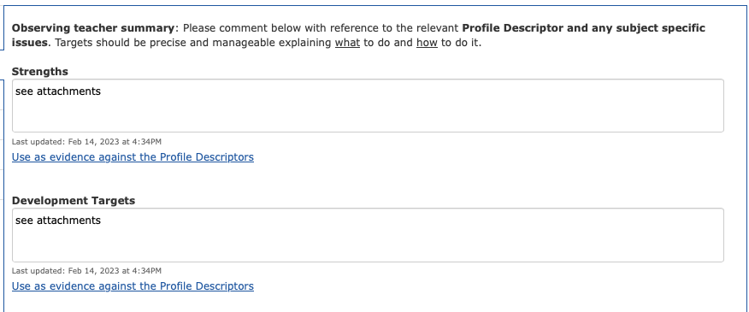
An extract from a recent lesson observation is typical of their current practice.

Strong subject knowledge
Confident delivery and develop use of school behaviour policy.

SK is pitched too high for the pupils
Over dwelling – they spend too long repeating the same learning point

They are not using assessment in the class so they are not aware what pupils know and don’t know. They have already grasped what you want them to know. How will you mentor this trainee to resolve this issue?

Other staff have mentioned that there is issues with their timing – they don’t get to the plenary in the lessons.
Timing is a frequent symptom of other issues.

Notes from the WDM 7 Feb
Timing was discussed. The trainee is not finishing the lesson with sufficient time to deliver the plenary and is spending too long on some sections. Last lesson they spent 35 minutes on the 5-minute starter.
Students were confused by the nature of the task, and while they made efforts to engagement productively, the lack of clarity led to a lot of confusion. This led to BM issues emerging.
Targets are focus on timing, and in class timing.
Trainee is not making progress and accumulating more targets. This is indicative of a lack of reflection.

Notes from the WDM 14 Feb
Targets are continued from the previous week and now include:
Understanding of pace to develop learning.
Use of assessment in the lesson (mini white boards were suggested)

The trainee has reflected on the WDM REFLECTION

We discussed lesson planning. I have improved my planning of lessons effectively and efficiently, reducing the time it takes me to plan. I have used spreadsheets to help me when writing my lesson plans and question sheets.
I have been teaching reduced hours the past few weeks as per my action plan. I have evidenced each area of the profile descriptor and will continue to do so as my hours increase again to show that I am meeting the standards.

What do you notice about the reflections? They are not very reflective. What questions should the mentor ask to promote deeper and more impactful reflection?
Notes – ability of the mentor to support trainees on Action plan

Questions for discussion at TD&C
What questions should we ask the trainee?
What are the next steps for this trainee?
Next steps? Reduced timetable? CFC? TSP? Continuing in the phase action plan?
What would you like to discuss at the next WDM?
Where does the trainee need support?
What makes a good reflection?
A good reflection is - not descriptive, action orientated, evaluative, sense of perspective, should focus on the things you can do tomorrow, next week to make a difference.

