Science ITAP 1

Planning for practical work Sept 2023

Aims
- To support you to develop your planning skills including:
  - Planning for student learning and progress
  - Planning for how to start and end lessons
  - Planning to manage equipment and resources
  - Anticipating possible problems and planning to avoid them
- To reflect as you synthesise knowledge from four different sources: university teaching sessions; academic and professional reading; observations in school; your own teaching experience in school.

Overall, this week will support you in becoming a professional teacher who can act with agency and integrity in the classroom.

The four sources of knowledge

University teaching sessions
We will explore the meaning of ‘effective practical work’ and using practical work for learning in science. You will have the opportunity to try out some more spectacular demonstrations and discuss your ideas with your peers.

Academic and professional reading
You will read and critique a range of texts.

School observations
Planning needs to be contextualised and the specific demands of each context will be different. You will observe and discuss planning with teachers in your school. We will support you in learning to observe teaching through watching video material and exploring the use of the Exeter tools.

Your own teaching experience
You should teach at least 4 short episodes in your two weeks in school.

Plan for the ITAP week

Day/Date | Tues 31/10 | 1/11 | 2/11 | TBD | 23/11
Location | Campus | Online/self-study | Campus | Your school (1.5 days) | Campus
Activities | Introduction: Planning for practical work | Readings  Critique Abrahams and Millar | Museum visit: planning for off-site activities | Complete at least [#] of the activities in the book | Peer teach session
 | Planning group task | Plan a practical lesson (individual task) |  | Plan, teach and be observed teaching at least two lesson segments | Chemistry demonstrations
 | Learning to observe teaching | Planning for demonstration |  |  | Tutorial – bringing all the ideas together
 |  | Plan for peer teach

Reading
Abrahams, I. and Reiss, M. (2017) Enhancing learning with effective practical science. London: Bloomsbury. Pages 5-27
Ian Abrahams & Robin Millar (2008) Does Practical Work Really Work? A study of the effectiveness of practical work as a teaching and learning method in school science, International Journal of Science Education, 30:14, 1945-1969, DOI: 10.1080/09500690701749305
Brookfield, S. (2005) Becoming a Critically Reflective Teacher. San Francisco. Jossey Bass.
EEF (n.d.) Improving secondary science. p.28-31. https://educationendowmentfoundation.org.uk/public/files/Publications/Science/EEF_improving_secondary_science.pdf
Ofsted (2021). Research review series: science. Research review series: science - GOV.UK (www.gov.uk) Practical work section

Recording your ITAP

There is a section in the IDP to upload your ITAP. For each ITAP you need to collect all the evidence into one upload.
Each ITAP will include:
- A reflection that relates to the 4 sources of knowledge above, (for example a Framework for reflection and some additional writing)
- Documents where you have observed other staff (e.g. demonstration or a lesson observation)
- Documents where you have implemented your observed practice (e.g. an Agenda, lesson observation, lesson plan)
- A record of the dates you have spent on ITAP
the document noted.

Introduction to the school-based activities
In the two weeks you are in school in November, different schools will be able to offer you different opportunities and experiences. Do not worry if your experience is different to your peers’.
Aim to carry out activity 1 to 4 and one (or more) from activity 5 and the reflection (activity 6) from this booklet, alongside beginning to teach short lesson episodes.
Discuss with your mentor which activities you will focus on.
Do not worry if you cannot carry out all the activities in this booklet, we are not expecting you to do so.
You can always carry out any of these activities that you think will be helpful in January and beyond.

Teaching lesson segments (Demonstration)
- Discuss with your mentor which classes and lesson segments you are going to teach.
- Use your observation notes (from the following pages) to help you to write an agenda for your segment.
- What is your phrase for asking for quiet? What exact words will you use?

Planning in your school context (Demonstration)
Find out if there are school policies regarding:
- Beginnings of lessons
- Lesson structure
- Behaviour expectations at different points in the lesson
- Endings of lessons
- How students are dismissed

Find out if there are science department policies regarding:
- Beginning of lessons
- Lesson structure
- Behaviour expectations at different points in the lesson
- Ends of lessons
- How students are dismissed
- Safety in practical lessons
- Which practical activities you can use in your lessons
Make notes on what you find out

Shadowing a lab technician (Demonstration)
Spend half a day shadowing a lab technician in your science department and finding out about their role. For example:
- What time do they arrive? Leave?
- How many lab techs are there in your department?
- Who are they and how are the responsibilities divided up between them?
- How many practicals do they each prep in a day on average? In a week?
- When do teachers need to order science practical equipment?
- How do they order?
- How will you be expected to order?
- In how much detail would the lab tech like the order?
- Do the lab techs have any other responsibilities (for example, risk assessing practicals, being a first aider, as a fire marshal)?
- Would they be willing to help you try out a practical or demonstration you wished to use in school? If so, is there a better time in the week for them to do that with you?

Observing beginnings and/or endings of lessons
(Demonstration and Agenda)
Aim to observe at least 2 lessons. These do not need to be science lessons. For example, if you shadow a pupil you could make notes on some of the lessons that you observe in that time.

Beginnings of lessons
- The subject and the year group.
- What type of class is this? What time does the lesson start? End?
- Where do the students wait at the start of the lesson?
- How does the teacher get the students into the room?
- (How) does the teacher greet the students?
- What are the students expected to do when they arrive in the room?
- How does the teacher ask the students to be quiet?
  - What exact words do they use?
  - What non-verbal communication do they use?
  - Where do they stand?
- Do they remind students of their expectations? How?
- What is the first activity students do? When?
- Does the teacher take a register? When and how?
- Does the teacher have different expectations for different segments of the lesson? (E.g. silent working, silent listening, quiet, sitting in their seat, moving around the room).
  - How are these expectations communicated to students?
- Does the teacher tell the students what they will be doing and learning in the lesson? If so, when and how?

Lesson endings
Make notes on what happens in the last 10 minutes of the lesson.

- What activity/activities take place in the last 10 minutes?
- Does the teacher introduce any new ideas/vocabulary?
- Does the teacher check student learning? How?
- Are there any resources to be collected? If so, how is this achieved?
- How does the teacher communicate their expectations?
- How is the class dismissed? What does the teacher say and do?

Follow up
If you can, discuss your observations with the class teacher and/or your mentor

Write an agenda for a lesson segment you will teach for the beginning or end of a lesson

How will you ask your classes to be quiet?
- What exact words will you use?
- Are these clear and unambiguous?
- What non-verbal communication might you use?

5a. Observing practical lessons 1: giving instructions
(Demonstration and Agenda)
You will need: watch, clock or stopwatch, paper (you may like both plain and lined), pen(s)

Make notes on:

- What year group/class/topic
- Learning objectives (shared with whole class and/or shared by teacher with trainees) and science content
- What time does the lesson start and finish?
- What time does the practical activity start and finish?

- How does the teacher begin the lesson?
- At what time does the teacher begin to explain the practical?
- How do they give practical instructions?
  - Visual (images, showing equipment)
  - Verbal (what is said)
  - Written (powerpoint, worksheet)
  - Other
- What procedural knowledge (how to do something) does the teacher expect the class to have?
- Can you spot any routines the teacher is using for the practical? If so, what? How might these have been set up?
- What, if any, safety rules does the teacher have for the practical? How are these shared and enforced?
- Choose a particular group of students.
  - Can these students follow the practical procedure/instructions?
(Are they successfully ‘hands on?’)
  - What evidence do you have?
  - How long does it take them to set up the kit (time it)?
  - How does this compare to other groups?
  - What (if any) issues do they run into?
  - How do they resolve them?
- Anything else that you noticed or learnt about carrying out practicals?

Discuss some of your findings with the class teacher and/or your mentor

Write an agenda that you will use when you are going to give instructions to a class (they do not have to be for a practical). You can adapt it later if you wish. Note that your teaching episode may not take place until January.

5b. Observing practical lessons 2: managing equipment
(Demonstration and Agenda)

You will need: watch, clock or stopwatch, paper (you may like both plain and lined), pen(s)

Make notes on:

- What year group/class/topic
- Learning objectives (shared with whole class and/or shared by teacher with trainees) and science content
- What time does the lesson start and finish?
- What time does the practical activity start and finish?

- How does the teacher give instructions about the practical equipment?
- What procedural knowledge do they expect the class to have?
- Can you spot any routines the teacher is using for managing the equipment? If so, what?

- How does the teacher get the practical equipment to the students?
- Sketch a diagram of the lab. Mark on:
  - Where the equipment is placed
  - Where the students do the practical task
  - If there are any bottle-necks of students then where do they occur? Why?

- Choose a particular group of students.
  - How long does it take them to gather the equipment (time it)?
  - What (if any) issues do they run into with getting and setting up the equipment?
  - How do they resolve them?

- Does the practical activity end at the same point for all students?

- How does the teacher manage the return of the equipment?
  - Do they check it has all been returned? How?
  - Are there any rewards or incentives for clearing up?
  - How does the teacher ensure that the room is ready for the next class?
- Anything else that you noticed or learnt about carrying out practicals?

Write an agenda that you will use when you need to manage resources in the classroom (they do not have to be practical resources). You can adapt it later if you wish. Note that your teaching episode may not take place until January.

5c. Observing practical lessons 3: learning through practical work
(Demonstration and Agenda)

- What year group/class/topic
- Learning objectives (shared with whole class and/or shared by teacher with trainees) and science content
- What time does the lesson start and finish?
- What time does the practical activity start and finish?

- How does the teacher begin the lesson?
- What (if any) activities are used prior to the practical?
  - E.g. recapping key words
  - Recapping previous subject content
  - Introducing new science content
  - Explaining the purpose of the practical

- Choose a particular group of students.
  - Can these students follow the practical procedure/instructions?
(Are they successfully ‘hands on?’)
  - Are these students discussing about the science? Are they ‘minds on?’
  - Are they using science words?
  - How did the teacher set up the activity to support them being minds on?

- Is there a follow up activity? If so, what?
- (How) are the students expected to use what they have learnt from the practical?
- Does the teacher point towards a future lesson for the follow up?
- Anything else that you noticed or learnt about carrying out practicals?

Discuss some of your findings with the class teacher and/or your mentor

Write an agenda that you will use when you teach a practical lesson or lesson segment. You can adapt it later if you wish. Note that your teaching episode may not take place until January.

Reflection on ITAP 1 Planning for practical work

Reflection is more than describing what happened. It is a critical part of improving your practice. It involves analysis what happened, talking and thinking about practice and looking forward to what you will do differently.
There are lots of different models that you can use for reflection, we have used Brookfield here.

“The critically reflective process happens when teachers discover and examine their assumptions by viewing their practice through four distinct, though interconnecting lenses”
(Brookfield, 2005 p xiii).

When you write your reflections you should comment on each of the 4 lenses

Lens of their own autobiography as teachers and learners
How our own experiences as learners can influence our behaviour as teachers.
Lens of students' eyes
How seeing ourselves through learners' eyes provides valid and reliable evidence for our practices as teachers and in particular how and what students are learning
Lens of colleagues experiences
How (as teachers) we need to feel credible in the eyes of learners, by creating safe spaces where we can have critical conversations with our colleagues we may be enabled to ‘check', ‘reframe' and broaden our practices
Lens of educational literature
How the literature was used as a ‘reliable mirror’ or an effective substitute for a critical friend, to hold up against our everyday teaching practices.

You should draw on examples that show what have you learnt about planning and planning for practical work from:
- The reading you have done
- The sessions on campus
- Observations of teachers
- Talking to lab technicians
- Talking to teachers
- Observing students in classes
- Your own teaching

Reflections are also forward looking.
You reflection should end with a comment about future practice.
What do you want to take forwards into your own teaching next term?
Which Exeter tools will you use to support you to do this?
What do you think are the top 5 key points that teachers should bear in mind when planning for purposeful practical work?
What are some of the challenges or issues teachers/you face when running practical lessons?
How can you plan to overcome some of these?

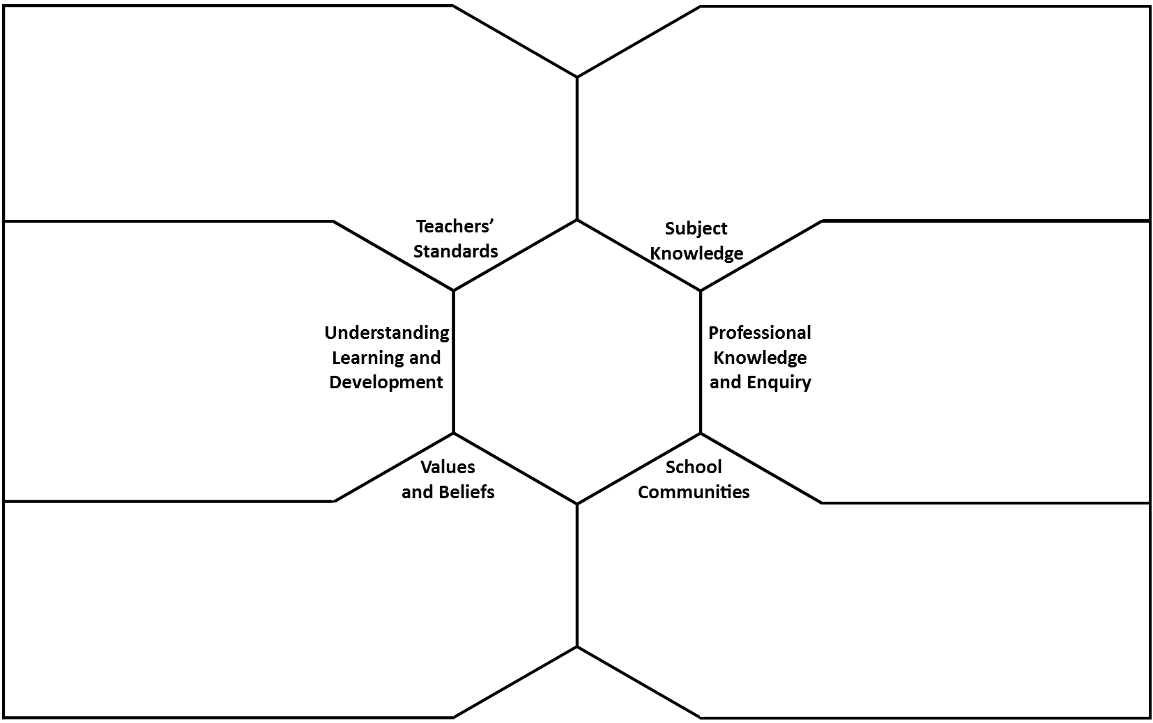
Planning for purposeful practical work

Planning for purposeful practical work

How does the concept of planning for purposeful practical work relate to each of the teachers’ standards?
What types of adaptive teaching might be needed to ensure all pupils can access purposeful practical work?
What are the requirements for practical work in the KS4 national curriculum for science?
What are required practicals and what are they for your subject?
How are required practicals assessed?
What are the requirements for practical work in KS3 science?
What are the requirements for practical work in your subject at KS5?
What teaching skills do you need to develop to ensure you can make effective use of practical work in science?
How has your past experience or your reading helped you to prepare for using practical work in science?
Which pieces of research have proved particularly influential on your thinking and your practice?
How easy do you expect it to be to translate the principles of purposeful practical work into practice?
What does effective use of practical work look like?
Do you think the KS4 practical work requirements help or hinder good practical science teaching?

What does research say about the merits of using practical work to support learning in science?
What does research say about how to ensure practical work leads to meaningful science learning?
What challenges do these theories present to your practice?
How do the science teachers communicate their requests for practical equipment to the lab technicians?
How might a school respond to pedagogical research on the best practices in using practical work in science?
Are there any conflicts between what you think you might want to do as a teacher and the ethos and practices of a school science department?

What practical work did you carry out at school?
How do your own experiences influence your beliefs about practical work?
What else is shaping your values and beliefs about practical work?
How might you convince a pupil of the value of a practical task (you can pick a specific one or just discuss in general)?
How might you convince a colleague of the value of practical work in science?

