Planning for effective practical work

ITAP week 1

Discuss in groups:
- Why might you want to do practical work in your science lessons?

- Rank your list from most to least important

Discuss:
- Do you have different priorities depending on your subject background?
- Does the order vary depending on the age of the students?
- What are some of the difficulties with doing practical work with students?

The hands-on and minds-on model

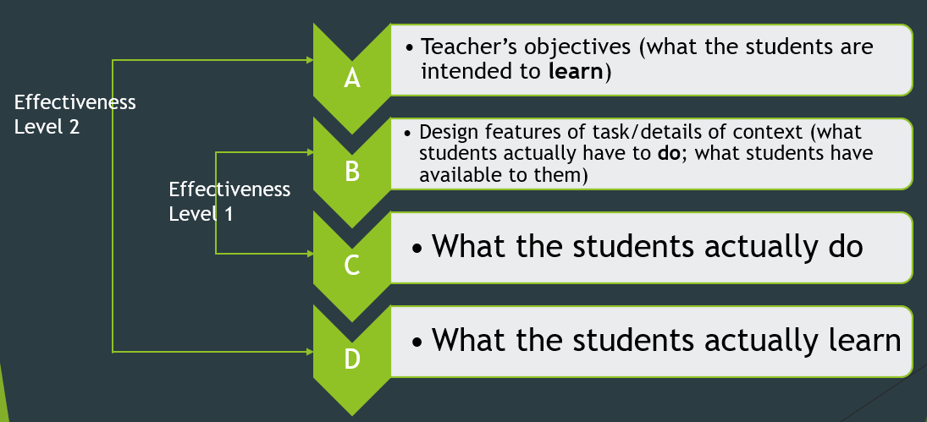

Task

- In groups, try out the practical activites – there are 6 so use your time carefully
- For each activity, honestly complete the Effectiveness Matrix in your booklet – it is more important that you complete this than that you try all 6 activities

Practical 1 Investigating the effect of different nerve pathways on reaction times
What honestly will students learn when doing this practical (concepts and practical skills?) | What are the practical’s limitations? What misconceptions might it produce, if any?
How might you improve the practical? How would you adapt it for a different year group? What other activities might go alongside to consolidate the learning for this practical? | What classroom management issues would this practical raise? How would you organise the practical in the lab – setting out, clearing up, counting equipment back in?

Practical 2 Comparing stomatal density on leaves
What honestly will students learn when doing this practical (concepts and practical skills?) | What are the practical’s limitations? What misconceptions might it produce, if any?
How might you improve the practical? How would you adapt it for a different year group? What other activities might go alongside to consolidate the learning for this practical? | What classroom management issues would this practical raise? How would you organise the practical in the lab – setting out, clearing up, counting equipment back in?

Practical 3 Diffusion of ions in solution – the case of lead iodide
What honestly will students learn when doing this practical (concepts and practical skills?) | What are the practical’s limitations? What misconceptions might it produce, if any?
How might you improve the practical? How would you adapt it for a different year group? What other activities might go alongside to consolidate the learning for this practical? | What classroom management issues would this practical raise? How would you organise the practical in the lab – setting out, clearing up, counting equipment back in?

Practical 4 Using Universal indicator to illustrate the process of neutralisation
What honestly will students learn when doing this practical (concepts and practical skills?) | What are the practical’s limitations? What misconceptions might it produce, if any?
How might you improve the practical? How would you adapt it for a different year group? What other activities might go alongside to consolidate the learning for this practical? | What classroom management issues would this practical raise? How would you organise the practical in the lab – setting out, clearing up, counting equipment back in?

Practical 5 Measuring the speed of moving objects
What honestly will students learn when doing this practical (concepts and practical skills?) | What are the practical’s limitations? What misconceptions might it produce, if any?
How might you improve the practical? How would you adapt it for a different year group? What other activities might go alongside to consolidate the learning for this practical? | What classroom management issues would this practical raise? How would you organise the practical in the lab – setting out, clearing up, counting equipment back in?

Practical 6 Efficiency and Energy transfer
What honestly will students learn when doing this practical (concepts and practical skills?) | What are the practical’s limitations? What misconceptions might it produce, if any?
How might you improve the practical? How would you adapt it for a different year group? What other activities might go alongside to consolidate the learning for this practical? | What classroom management issues would this practical raise? How would you organise the practical in the lab – setting out, clearing up, counting equipment back in?

What other questions would you ask about practicals that will help you decide what practicals to do and why are you doing them?

